# *A Summer Training Report of*

***“RAJ WAFERS PRIVATE LIMITED.”***

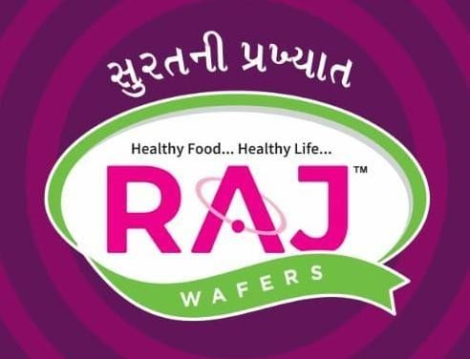

*Submitted by:* 179 Mansi Savaj

*235 Pransi Jasoliya*

*267 Jay Patel*

*142 Hepins Kasodariya*

*147 Brijesh Kumbhani*

*T.Y.B.B.A Semester -V*

*In partial fulfilment of the requirement for the degree of*

***BACHELOR OF BUSINESS ADMINISTRATION***

Under the guidance of **MS. Sweta Ma’am** *Submitted to:*

***Dr.Mukesh Goyani***

***PROF.V.B. SHAH INSTITUTE OF MANAGEMENT,***

***Affiliated***

***VEER NARMAD SOUTH GUJARAT UNIVERSITY, SURAT***

***August – 2022***

***DECLARATION***

I, *Mansi Savaj* undersigned, a student of **Prof. V.B. Shah Institute of Management,** Surat, declare that the Summer Training project report conducted on “***RAJ WAFERS PRIVATE LIMITED.*”** from 28th APRIL 2022 to 5th prepared Under Guidance of MS. Sweta Ma’am Asst. Professor & submitted to MS. Sweta Ma’am**,**Asst. Professor of **Prof. V.B. Shah Institute of Management, Surat.**

This is my own work & the report prepared there in is based on my study and experience, during the tenure of my study.

I will not use this project report in future and will not submit the same to any other university or institute or any other publisher without written permission of my guide

I further declare that the result of my findings & research in the subject is original in nature and has not been previously submitted either in part or in whole to any other institute or university for any degree. If it is found, I shall be only responsible for its consequences.

Place: Amroli, Surat Date:

### (Student Sign)

*Mansi Savaj*

*ROLL NO 179*

***DECLARATION***

I, Pransi *Jasoliya undersigned*, a student of **Prof. V.B. Shah Institute of Management,** Surat, declare that the Summer Training project report conducted on “***RAJ WAFERS PRIVATE LIMITED.*”** from 28th APRIL 2022 to 5th JUNE prepared Under Guidance of MS. Sweta Ma’am Asst. Professor & submitted to MS. Sweta Ma’am**,** Asst. Professor of **Prof. V.B. Shah Institute of Management, Surat.**

This is my own work & the report prepared there in is based on my study and experience, during the tenure of my study.

I will not use this project report in future and will not submit the same to any other university or institute or any other publisher without written permission of my guide

I further declare that the result of my findings & research in the subject is original in nature and has not been previously submitted either in part or in whole to any other institute or university for any degree. If it is found, I shall be only responsible for its consequences.

Place: Amroli, Surat Date:

### (Student Sign)

*PRANSI JASOLIYA* ROLL NO 235

***DECLARATION***

I, Jay *Patel* undersigned, a student of **Prof. V.B. Shah Institute of Management,** Surat, declare that the Summer Training project report conducted on “***RAJ WAFERS PRIVATE LIMITED.*”** from 28th APRIL 2022 to 5th JUNE prepared Under Guidance of MS. Sweta Ma’am Asst. Professor & submitted to MS. Sweta Ma’am**,** Asst. Professor of **Prof. V.B. Shah Institute of Management, Surat.**

This is my own work & the report prepared there in is based on my study and experience, during the tenure of my study.

I will not use this project report in future and will not submit the same to any other university or institute or any other publisher without written permission of my guide

I further declare that the result of my findings & research in the subject is original in nature and has not been previously submitted either in part or in whole to any other institute or university for any degree. If it is found, I shall be only responsible for its consequences.

Place: Amroli, Surat Date:

### (Student Sign)

###### *JAY PATEL* ROLL NO 267

***DECLARATION***

I, *Hepins Kasodariya* undersigned, a student of **Prof. V.B. Shah Institute of Management,** Surat, declare that the Summer Training project report conducted on “***RAJ WAFERS PRIVATE LIMITED.*”** from 28th APRIL 2022 to 5th JUNE prepared Under Guidance of MS. Sweta Ma’am Asst. Professor & submitted to MS. Sweta Ma’am**,** Asst. Professor of **Prof. V.B. Shah Institute of Management, Surat.**

This is my own work & the report prepared there in is based on my study and experience, during the tenure of my study.

I will not use this project report in future and will not submit the same to any other university or institute or any other publisher without written permission of my guide

I further declare that the result of my findings & research in the subject is original in nature and has not been previously submitted either in part or in whole to any other institute or university for any degree. If it is found, I shall be only responsible for its consequences.

Place: Amroli, Surat Date:

### (Student Sign)

###### *HEPINS KASODARIYA*

*ROLL NO 142*

***DECLARATION***

I, *Briesh Kumbhani* undersigned, a student of **Prof. V.B. Shah Institute of Management,** Surat, declare that the Summer Training project report conducted on “***RAJ WAFERS PRIVATE LIMITED.*”** from 28th APRIL 2022 to 5th JUNE prepared Under Guidance of MS. Sweta Ma’am Asst. Professor & submitted to MS. Sweta Ma’am**,** Asst. Professor of **Prof. V.B. Shah Institute of Management, Surat.**

This is my own work & the report prepared there in is based on my study and experience, during the tenure of my study.

I will not use this project report in future and will not submit the same to any other university or institute or any other publisher without written permission of my guide

I further declare that the result of my findings & research in the subject is original in nature and has not been previously submitted either in part or in whole to any other institute or university for any degree. If it is found, I shall be only responsible for its consequences.

Place: Amroli, Surat Date:

### (Student Sign)

###### *BRIJESH KUMBHANI*

*ROLL NO 147*

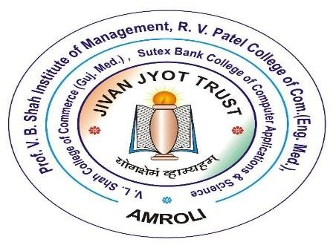

**PROF V.B. SHAH INSTITUTE OF MANAGEMENT**

R.V. PATEL COLLEGE OF COMMERCE (E.M)

V.L. SHAH COLLEGE OF COMMERCE (G.M)

SUTEX BANK COLLEGE OF COMPUTER APPLICATIONS & SCIENCE,

**AMROLI, SURAT**

***FACULTY GUIDE CERTIFICATE***

*This is to certify that Miss.* MANSI SAVAJ *Roll.N0 179 a student of* ***TYBBA (Sem-V)*** *from* ***Prof. V.B. Shah Institute of Management, Amroli,*** *affiliated to Veer Narmad South Gujarat University, Surat, has done* ***her*** *Summer Training project work from 28th April to 5th JUNE. The*

*project work Conducted on “****RAJ WAFERS PRIVATE LIMITED****” Industry*

*embodies the original work done by him/her.*

|  |  |
| --- | --- |
| MS. Sweta Ma’am PROJECT GUIDE  ASSISTANT PROFESSOR | DR. MUKESH R. GOYANI  PRINCIPAL |

***FACULTY GUIDE CERTIFICATE***

*This is to certify that Miss.* PRANSI JASOLIYA *Roll.N0 235 a student of* ***TYBBA (Sem-V)*** *from* ***Prof. V.B. Shah Institute of Management, Amroli,*** *affiliated to Veer Narmad South Gujarat University, Surat, has done* ***her*** *Summer Training project work from 28th April to 5th JUNE. The*

*project work Conducted on “****RAJ WAFERS PRIVATE LIMITED****” Industry*

*embodies the original work done by him/her.*

|  |  |
| --- | --- |
| MS. Sweta Ma’am  PROJECT GUIDE  ASSISTANT PROFESSOR | DR. MUKESH R. GOYANI  PRINCIPAL |

#### *FACULTY GUIDE CERTIFICATE*

*This is to certify that Mr.* JAY PATEL *Roll.N0 267 a student of* ***TYBBA (Sem-V)*** *from* ***Prof. V.B. Shah Institute of Management, Amroli,*** *affiliated to Veer Narmad South Gujarat University, Surat, has done* ***his*** *Summer Training project work from 28th April to 5th JUNE. The*

*project work Conducted on “****RAJ WAFERS PRIVATE LIMITED****” Industry*

*embodies the original work done by him/her.*

|  |  |
| --- | --- |
| MS. Sweta Ma’am  PROJECT GUIDE  ASSISTANT PROFESSOR | DR. MUKESH R. GOYANI  PRINCIPAL |

#### *FACULTY GUIDE CERTIFICATE*

*This is to certify that Mr.* HEPINS KASODARIYA *Roll.N0 142 a student of* ***TYBBA (Sem-V)*** *from* ***Prof. V.B. Shah Institute of Management, Amroli,*** *affiliated to Veer Narmad South Gujarat University, Surat, has done* ***his*** *Summer Training project work from 28th April to 5th JUNE. The*

*project work Conducted on “****RAJ WAFERS PRIVATE LIMITED****” Industry*

*embodies the original work done by him/her.*

|  |  |
| --- | --- |
| MS. Sweta Ma’am  PROJECT GUIDE  ASSISTANT PROFESSOR | DR. MUKESH R. GOYANI  PRINCIPAL |

#### *FACULTY GUIDE CERTIFICATE*

*This is to certify that Mr.* BRIJESH KUMBHANI *Roll.N0 147 a student of* ***TYBBA (Sem-V)*** *from* ***Prof. V.B. Shah Institute of Management, Amroli,*** *affiliated to Veer Narmad South Gujarat University, Surat, has done* ***his*** *Summer Training project work from 28th April to 5th JUNE. The*

*project work Conducted on “****RAJ WAFERS PRIVATE LIMITED****” Industry*

*embodies the original work done by him/her.*

|  |  |
| --- | --- |
| MS. Sweta Ma’am  PROJECT GUIDE  ASSISTANT PROFESSOR | DR. MUKESH R. GOYANI  PRINCIPAL |

#### *ACKNOWLEDGEMENT*

The internship opportunity we had with Raj Wafers was a great chance for learning and professional development. Therefore, we consider ourself a very lucky individual as we were provided with an opportunity to be a part of it from VNSGU. We are also grateful for having a chance to meet so many wonderful people and professionals who led us through this internship period.

We would like to express our deep gratitude to Mrs. Shweta Rajput our subject guide, Dr. Swati Mehta Co - Ordinator, and other faculty member and college management for their helpful co-operation and guidance, without which our efforts would have never been materialized in such worth. Their inspiration and encouragement have led us to come up with a successful task.

It is our radiant sentiment to place on record our best regards, deepest sense of gratitude to Mr. Amit Sheta and Dharmesh Sheta [managing directors], Mr. Nirav Rathod, [HR], for their careful and precious guidance which were extremely valuable for our study both theoretically and practically.

We perceive this opportunity as a big milestone in our career development. we will strive to use gained skills and knowledge in the best possible way, and we will continue to work on their improvement, in order to attain desired career objectives.

Place: Surat

Date: 08th June 2022.

***EXECUTIVE SUMMARY***

*Company Name :- RAJ WAFERS PRIVATE LIMITED.*

*Since 2003*

*Contact Person :-* Mr. Amit Sheta [Owner]

Dharmesh Sheta [Managing Directors], Mr. Nirav Rathod[HR].

Raj wafers is a company which’s known for it’s wafers and namkeens. They covers almost Surat and near their all cities. It’s provides more than 15 flavors of different wafers and 4 to 5 types of namkeens. Balaji Wafers is the most famous competitors for the Raj Wafers.

*Problem statement :-*

*In recent customer feedback sessions, 52% of customers have expressed a need for a simpler and cheaper version of Wafers. In surveys of customers who have chosen competitor wafers, price. is mentioned 87% of the time. To best serve our existing customers, and to branch into new markets, company need to develop their products that they can sell at an appropriate price point for this market.*

*Proposed solution :-*

*Companies new wafers will begin at 20% cheaper than current cheapest option, with the potential for 40%+ cheaper options depending on material and movement. In order to offer these prices.*

**TABLE OF CONTENTS (INDEX)**

**CHAPTER1: GENERAL INFORMATION** ..................................

1.1 ABOUT COMPANY ………………………………...

* 1. COMPANY PROFILE ………………………….
     1. HISTORY OF RAJ WAFFERS……….
     2. VISION OF RAJ WAFERS …………………
     3. FUTURE PLAN AND MISSION OF RAJ WAFERS ………………
  2. LIST OF PRODUCTIONS ………….
  3. INDUSTRIAL DETAILS ………………………...

1.5 COMPETITORS …………………………………...

* 1. LIST OF DEALERS …………………...
  2. GROWTH OPPORTUNITIES IN INDIAN FMCG INDUSTRY

**CHAPTER 2: - PRODUCTION DEPARTMENT**

* 1. PRODUCTION PLANNING

###### *Organization structure of production department*

* 1. *Raw material purchase policy*
  2. *Resources of material*
  3. *Process of production*
  4. *Plant location considering various factor*
  5. *Material handling equipment*
  6. *Equipment*
  7. *Types of Inventory control*
  8. *ABC Inventory control*
  9. *Inventory management techniques*
  10. *EOQ model*
  11. *Storage department*
  12. *Material receipt procedure*
  13. *Material issue procedure*
  14. *Planned maintain*
  15. *Quality control system*

**CHAPTER 3: - MARKETING DEPARTMENT** …………………….

##### Introduction……………………………

* 1. Objective of marketing department
  2. Organization structure of marketing department
  3. Customer segmentation and target marketing
  4. Target Marketing
  5. Sales procedure
  6. Order processing system
  7. Philosophy of marketing
  8. Distribution channel
  9. Activity of distribution
  10. Product life cycle and its marketing strategy
  11. Packaging & labelling of raj wafer
  12. 4 p’s of raj wafer: -
      1. Product
      2. Price
      3. Promotion
      4. Place

**CHAPTER 4: - FINANCE DEPARTMENT**.........................

##### INTRODUCTION OF FINANCE DEPARTMENT ……………

* 1. PROFIT & LOSS ACCOUNT OF COMPANIES……………………..
  2. BALANCE SHEET OF COMPANIES ……………………………..
  3. RATIO ANALSIS OF COMPANIES ………………………….
  4. FINANCIAL STATEMENT ANALYSIS…………………………
  5. CSR AND EXPENSE OF COMPANIES………………………
  6. ACCOUNTING PROCEDURE……………………

**CHAPTER 5: - HUMAN RESOURCE DEPARTMENT**…………………

* 1. INTRODUCTION……………………….
  2. RECRUITMENT & SELECTION PROCESS ………………
  3. NUMBER OF EMPLOYEES ……………………
  4. Attendance maintenance ……………...
  5. TRAINING given…………………
  6. Fringe benefits provided …………...
  7. EMPLOYEE SAFETY MECHANISMS…………………...
  8. SPECIFIC HR POLICIES……………………
  9. PERFORMANCE APPRAISAL PROCESS ………………………
  10. WAGES & SALARY ADMINISTRATION…………………...
  11. GRIEVANCEHANDLINGPROCEDURE…………………………………….

***CHAPTER 1: - GENERAL INFORMATION***

###### *ABOUT COMPANY*

* *Organization name :- RAJ WAFERS*
* *Organization address :- Plot no. 2, A/12, Shagun industrial estate, Olpad Road, Atodara,*

*Surat-394130, Gujarat, India.*

* *Contact Person name :- MR. Nirav Rathod, HR*
* *Contact number :- 9313801931*
* *No. of employee :- 70*
* *No. of department in :- 5 (Marketing, H.R.M, Finance, Organization Production, Packaging)*
* *Type of business :- Manufacturer/Supplier/Exporter*
* *Owner :- MR. Amit Sheta*
* *Chairman :- MR. Dharmesh Sheta*
  + 1. *Company Profile*

###### *HISTORY OF RAJ WAFERS :-*

*Established in the year 2003, just before 19 years, ‘Raj* Wafers’, are instrumental in manufacturing, supplying, wholesaling and exporting a wide range of wafers and namkeens. These eatables are hygienically processed at our state-of-the-art infrastructure. Our product is highly demanded by the customers for their freshness, nutritive value, great test and longer shelf life. Premium quality packaging of our products helps in keeping the products fresh and crisp for a longer period of time. These eatables are available in various flavors and test to cater to the different requirements of the clients. We have fostered long term business relations with our vendors to fulfill our commitments to our clients by providing them with the products as per their requirements and specifications in a timely manner. Our efficient supply network allows us to promptly deliver products as and when required. Converting over the area near to 29 plots in the outskirts of Surat city. RAJ WAFERS group has 70% of wafers and 30% of Farali Chevda currently.

*Under the guidance of our mentor, Mr. Amit Sheta, I have* been able to establish myself as a reputed brand in the industry. His years of experience and huge knowledge and transparent business policies have enabled us to lead over the competitors. Our client-centric approach and ethical business policies have enabled us to build a vast customer base. In addition, our customers can purchase these products at leading prices

*Due to the efforts of our mentor, Mr. Amit Sheta, His expert* supervision and suggestion have enabled us to maintain consistency in the quality of eatables. They only goal of business which is as follows:

***“HEALTHY FOOD .... HEALTHY LIFE. ”***

*Firstly, only Amitbhai was the owner but now too his brother* joins the company Dharmesh Bhai Sheta. First only one frying machine was their total manual work for 2 years. Then the plant was shifted to DELAD (nr. Sayan), there more 3 frying machines were launched with more systems and

*technologies. This reduced the pressure of the managers about the workload.* Again, the plant has shifted to ATODARA for the last 6 years. By the overwhelming success, they were inspired to set a plant. Instead of preparing wafers by tradition method, this new plant boosted the quality, test and more sales and to have hygiene auto system.

###### *Vision of Raj wafers :-*

*The vision of the company is that they make at least one* product for every occasion is a clear-cut vision of RAJ WAFERS. This meets the buying capacity of an average Indian and it also reflects the motto to provide the best quality product line.

###### *Future Plans and Mission of RAJ WAFERS :-*

*Raj wafers perceived growth rather than development* to the sky. The company will enhance its product range by adding some futuristic and Indian test companies will plan some extruded snacks and western products to their global market. Recently the company has acquired more space where its entire namkeen unit will be shifted. The future will see more of Dharmesh Bhai Sheta as a chairman, Amitbhai Sheta as an owner of the company, at Raj Wafers progress is a life line. The journey of Raj wafers in 2003 by the members of the Sheta family. For supplying wafers and snacks to local brands to the Surat. Due to the shore supply of that product they decided to make their own product line in 2006.

#### *List of Products :-*

1. *Salted Chips*
2. *Mori Chips*
3. *Tomato Chips*
4. *Cream N Onion Chips*
5. *Farali Chevda – Tikha*
6. *Farali Chevda – Mitha*
7. *Banana Chips*
8. *Cheese Garlic Chips*
9. *Masala Chips*
10. *PaniPuri Chips*
11. *Chilly Chaska Chips*
12. *Lemon Pepper Chips*

###### *Salted Chips: -*

*Salted is the very classic and initial product of Raj Wafers. It*

*only contains iodized salt in the required amount.*

###### *Mori Chips: -*

*Mori chips are nothing but unflavored chips directly ready*

*from frying.*

###### *Tomato Chips: -*

*Tomato flavored chips are very famous in both rural and* urban areas of Gujarat. It contains sugar, Dehydrated vegetable powder, spices, chili powder, cumin powder, Acidity Regulator, Anticaking Agent etc.

###### *Cream N Onion: -*

*Cream N Onion is mainly of Onion flavored chips which* contain milk solids, Onion powder, Sugar, Iodized Salt, and other ingredients.

###### *Farali Chevda – Tikha:-*

*Raj wafers have an increasing market of farali chevda. Tikha* chevda contains Potatoes, Oil, Peanuts, Sugar, Dry Mango Powder, Rock Salt, Black Salt, Chili Powder, Turmeric Powder, Acidity Regulator and Other Spices.

###### *Farali Chevda – Meetha: -*

*Meetha Farali Chevda contains Potatoes, Edible oil, Peanuts,* Sugar, Cashew Nuts, Raisins, Kismis and other ingredients.

###### *Banana Chips: -*

*Raj wafers have recently developed Banana chips and it shows* great market opportunities to them, it contains Banana, Edible oil, Black pepper, Salt, and other ingredients.

###### *Cheese Garlic: -*

*This chip contains potatoes, Edible vegetable oil, Dextrose, salt,* Cheese powder, Mozzarella Cheese Powder, Gouda Cheese Powder, Garlic, Chili, Onion, Black pepper, Oleoresin Paprika, Milk Ingredients etc.

###### *Masala Chips: -*

*Masala chips contain Potatoes, Edible vegetable oil,* Maltodextrin, Spices and condiments, Salt, Black salt, Tomato Powder, Hydrolyzed vegetable Protein, Food Acids etc.

###### *Pani Puri Chips: -*

*Pani Puri flavored chips contain Potatoes, Edible Oil,* Maltodextrin, Spices and Condiments, Tamarind Powder, Mint Powder, Salt, Black Salt, Sugar etc.

###### *Chilly Chaska Chips: -*

*Chilly Chaska chips contain Potatoes, Edible oil, Red Chili, Rock* salt, Cinnamon Powder, Turmeric powder, Clove Powder, Green Chili, Dry Mango Powder, Acidity Regulator etc.

###### *Lemon Pepper Chips: -*

*Lemon pepper chips contain Potatoes, Edible vegetable oil, Rock* salt, Maltodextrin, black pepper, Lemon Powder, Dry mango powder etc.

###### *INDUSTRIAL DETAILS :-*

|  |  |  |
| --- | --- | --- |
| *ITEMS* | *EARLIEAR* | *CURRENTLY* |
| *WAFERS* | *60%* | *40%* |
| *NAMKEENS* | *40%* | *20%* |

*The product firstly was nankeens and chips but at delay,* they have more concentration on chips than nankeens due to more profit's margins. All the products are only potato related food items which are as follow:

*Firstly, they selling were in only in local area but its unbiased* and neutral views have been appreciated by one and all. With an average daily production of 5oo kg pre hr. It is not merely a cattery but it now resides as a test in the tongues of the customer.

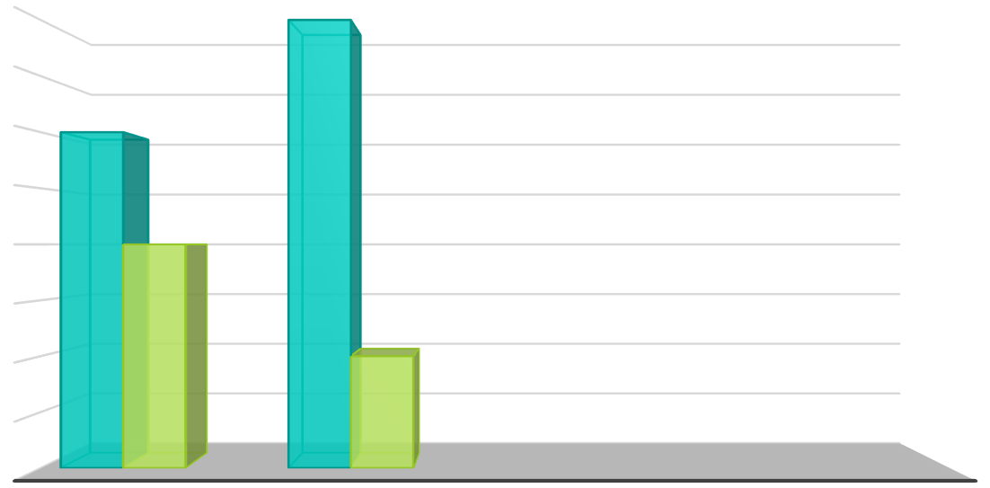

80

70

60

50

40

30

20

10

0

EARLIER

CURRENTLY

WAFERS NAMKEENS

#### *The fame of test reached the regions like…*

* *Surat*
* *Mehsana*
* *Visnagar*
* *Ankleswar*
* *Baroda*
* *Bharuch*
* *Kukarwada*
* *Gandhinagar*
* *Ahmedabad*
* *Sidhdhapur And state like, Rajasthan Maharashtra.*

#### *COMPETITORS*

*The competitors of raj wafers are: -*

* + *Balaji*
  + *Real*
  + *Gopal namkeen*
  + *Euro*
  + *Vimal fresh*

#### *LIST OF DEALERS :-*

|  |  |
| --- | --- |
| ***PLACE*** | ***NO. OF DEALERS*** |
| *Surat* | *10* |
| *BHARUCH* | *15* |
| *ANKLESHWAR* | *13* |
| *BARODA* | *20* |
| *AHMEDABAD* | *15* |
| *VISNAGAR* | *11* |
| *MEHSANA* | *18* |
| *KUKARWADA* | *10* |
| *SIDHDHAPUR* | *12* |
| *RAJASTHAN* | *19* |
| *MAHARASHTRA* | *12* |

###### *GROWTH OPPORTUNITIES IN INDIAN FMCG INDUSTRY* :-

* ***Rural market: -***
* *Leading players of consumer products have a strong distribution network in rural India; they also stand to gain from the contribution of technological advances such as internet and e- commerce to better logistics.*
* *Rural FMCG market size is expected to touch USD 100 billion by 2025.*

#### *Innovation products: -*

* *Indian consumers are highly adaptable to new and innovative products. For instance, there has been an easy acceptance of men’s fairness creams, flavored yoghurt, and cuppa mania noodles.*

#### *Premium product: -*

* *With rise disposable income mid and high-income consumer in urban areas have shifted their purchase trend from essential to premium products.*
  + *In response, firms have started enhancing their premium product portfolio.*

#### *Sourcing base: -*

* *Indian and multinational FMCG players can leverage India as strategic sourcing hub for cost-competitive product development and manufacturing to cater to international market.*

#### *Penetration: -*

* + *Low penetration levels offer for growth across consumption categories.*
  + *Major players are focusing on rural market to increase their penetration in those areas.*

# * *CHAPTER 2 :- PRODUCTION DEPARTMENT*

## *Production Planning*

###### *Introduction of production*

* *Organization structure of production department*
* *Raw material purchase policy*
* *Resources of material*
* *Process of production*
* *Plant location considering various factor*
* *Material handling equipment*
* *Equipment*
* *Types of Inventory control*
* *ABC Inventory control*
* *Inventory management techniques*
* *EOQ model*
* *Storage department*
* *Material receipt procedure*
* *Material issue procedure*
* *Planned maintain*
* *Quality control system*
  1. *ORGANIZATIONSTRUCTURE OF PRODUCTIONDEPARTMENT*

President

General

Manager

Vice manager

Production department

Purchasing

producing

quality control

store control

* + - *INTRODUCTION OF PRODUCTION*

*“Production means any activity which adds to the GDP of the nation of* economy.” “Production is the process of converting the raw material or other inputs into the products for further production or the finished goods or services, so that the utility of inputs is an enhanced and the needs of the customer are satisfied.”

###### *RAW MATERIAL PURCHASE POLICY*

*The process describes the sequence of steps leading to the completion of* an identified specific task. Thus, purchasing process describes the sequence of steps by which purchase function is carried though from its inception to it completion.

Raw material

type

Solid

Liquid

Potatoe

Chat masala

Water

Oil

###### *RESOURCES OF MATERIAL*

1. *INTERNAL*
2. *EXTERNAL*
3. ***INTERNAL***

* *CHAT MASALA*

*They are used to make flavored chips. The masala is* added in the flavor applicator and gets mixed with the chips thoroughly. Here the ingredients are bought and workers mix all the ingredients and at last masala gets prepared.

###### *WATER*

*Water is used almost at every step for washing. Firstly,*

*washing of potatoes, then chips are washed before frying. Water is used in all* the machineries.

1. ***EXTERNAL***

*The potatoes are brought from different states in different seasons.*

###### *POTATOS*

*They are the main sources to prepare chips. Potatoes used*

*are to be brought of different quality in different seasons from various states.*

###### *OIL*

*Oil is used to fry the chips. Oil is brought from external* source in wholesale. The ingredients of masala are to be brought from the shops. E.g., salt, pepper, sugar, chili powder, garlic powder etc.

###### *PROCESS OF PRODUCTION*

ELEVATER

GRADER

DISTONER

PEELER

INSPACTION CONVELT

VERTICAL ELEVATOR

CC FEEDER

SLICER

SLICER WATER TUBE

SLICER WATER SHAKER

BLANCHER FRIER

SHAKER

HIGE SPEED BELT

FRIER

DE OILING BELT

INSPECTION BELT

FLAVOUR APPLICATOR

FLAVOUR DRUM

1. *ELEVATOR*

*Conveyer belt which gives potatoes to grader. It moves*

*potatoes for further process and this is the step of the process. The workers lift* the bags of potato bags to put the potato in the elevator.

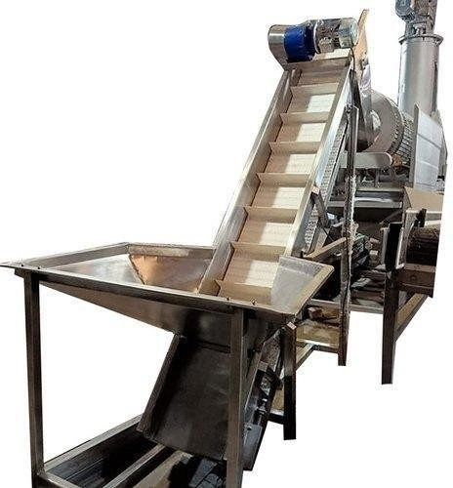

###### *GREADER*

*It does the works of taking in and out potatoes. There is*

*a plate placed of 25mm in which the wastage of potatoes is thrown out and* pushes the potatoes to the next position. This is the second step of process. The potatoes are coming from elevator and goes in the grader. The potatoes are

*shacked and cleaned so that sand particles left in the grader and then potatoes* pushed in the next step.

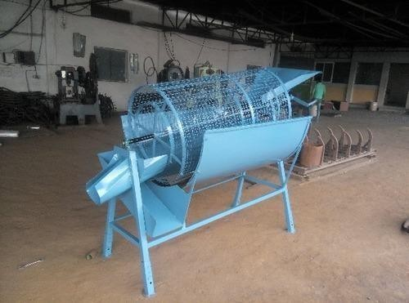

###### *DISTONER*

*This is the third step. When the potatoes are shacked,*

*they are washed up the distoner. This machine contains the water in it and* potatoes are thoroughly washed. Sand particles and other things are removed in the distoner and water is also thrown out.

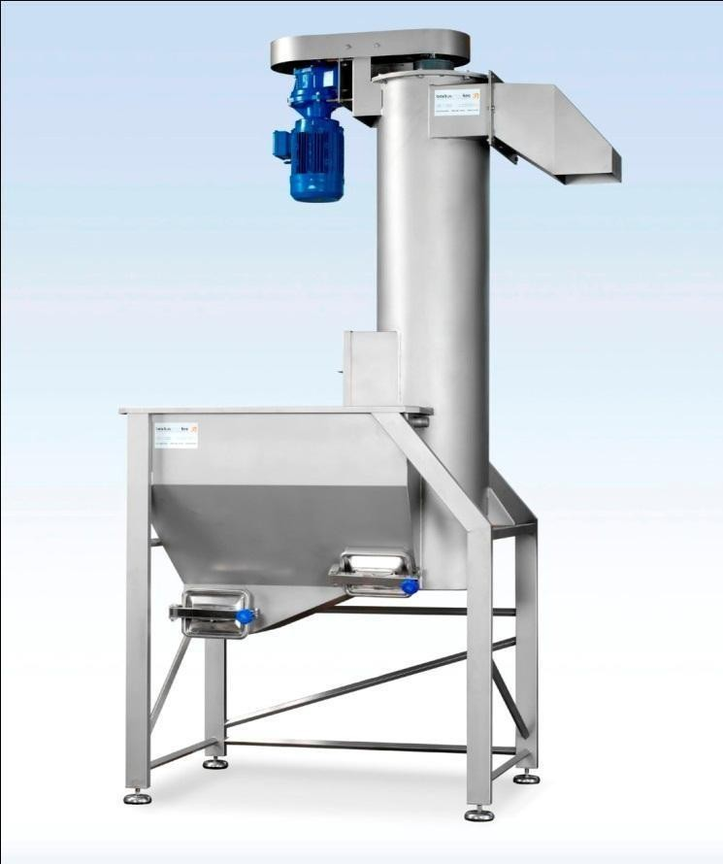

###### *PEELER*

*When the potatoes come from the destoner they are peeled*

*off in the peeler. Peeler does two tasks at a time. Peeler roll: it does the work of* peeling the potatoes. Peelings come out from the machine. Peeler agar: it pushed the potatoes to the next position.

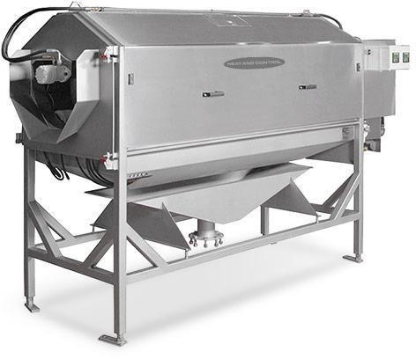

###### *INSPECTION BELT*

*Here the potatoes are cut off if they are in damaged* condition. If half parts of potatoes are damaged the workers are there to cut off the damaged part and then it is pushed to the next position in the vertical elevator.

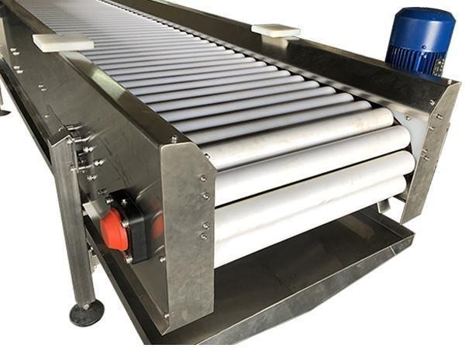

###### *VERTICAL ELEVATOR*

*There are many potatoes in the inspection belt. All the* potatoes at the same time cannot be made into chips. So, it is the work of a vertical elevator to put the potatoes in a group and move to the next process.

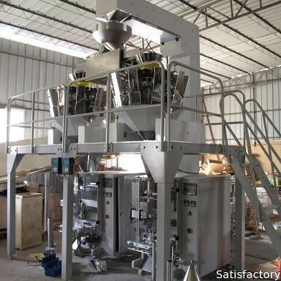

###### *CC FEEDER*

*The potatoes in the cc feeder are placed in a line and*

*moved forward to the next position. When the potatoes are going in bulk, this* keeps every potato in the line and moves to the slicer.

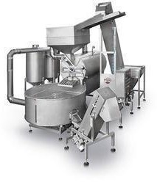

###### *SLICER*

*The potatoes are cut in the slicer of various types. The*

*cutting dye is placed so the potatoes are cut in slices. Chips and Farali chevda* both are cut hair. The chips are the same size and shape. Farali Chevda can be of different size, small and big both. There are different types of dies for making normal chips, creepy chips, farali chevda etc. which need to change from time to time in the intervals of 2-3 hours.

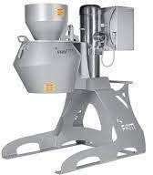

###### *SLICER WASHER TUBE*

*The starch which is present in the potatoes is taken out then* they are washed and wastage is removed. Some amount of starch is not beneficial for our body and so it has to be taken out. Slicer washer taken does this work of removing unnecessary starch.

###### *SLICER WASHER SHAKER*

*Chips are made and they are also to be removed. The chips are* of the same size, if the sizes are big, they are cut off automatically which are taken out as wastage and they are thrown off. The chips when sliced and starch is removed, the washing of chips is done

###### *BLANCHER*

*Chips are heated here at 50 degrees Celsius and it is fried in a* blancher. The chips are arranged in such a way automatically that they do not remain unfried.

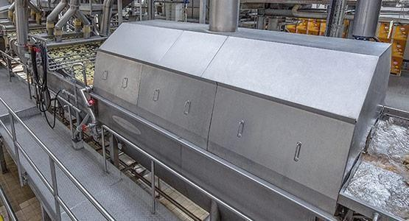

###### *SHAKER*

*Wastage is removed in this, unwanted remaining of the chips is*

*removed. They are cut off automatically and they cannot be reused. So, the* shape and size are maintained in the shaker.

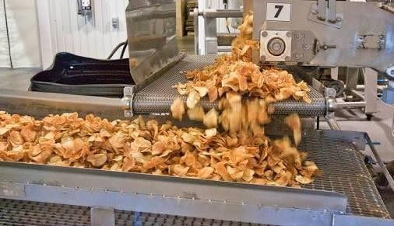

###### *HIGH SPEED BELT*

*In a high-speed belt, the chips are dried up to help full force of hot* air. Then the chips are moved forward through the belt called high speed belt.

###### *FRYER*

*Fryer does four works at one line. a. Paddle: - it pushes ahead*

*of the chips to the next position. b. Submerges: - It deeps the chips according to* the production quality needed. c. Take out d. Fryer filter: - the wastage is removed which is over fried. The temperature of oil in the fryer needs to be checked timely.

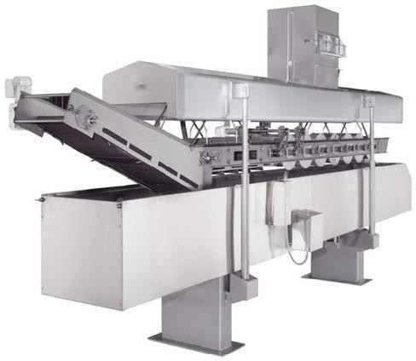

###### *DE OILING BELT*

*If the oil in the machine is increased, the machine* automatically produces the sound and then it decreases the amount of oil and unwanted oil is removed.

###### *INSPECTION BELT*

*Here the two persons are placed to take out over fried* wastage chips having more sugar. They are taken out and not reused. The single chip inspection is done here.

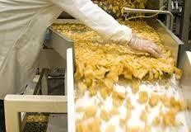

###### *FLAVOUR APPLICATOR*

*This adds flavor masala to the wafers. As the masala is made in* the company itself, the masala is added in the flavor applicator.

###### *FLAVOUR DRUM*

*It is a rolling cylindrical drum which mixes the chips with* masala. Flavor drum mixes the masala so nicely that none another chip remains unflavored.

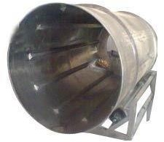

###### *PACKAGING*

*Company has two big fully automatic machines for*

*packaging differently. packets of different weight. And also add Nitrogen gas* automatically. They are very fast and can pack up to 70 bags per minute. It requires different rolls of packaging material. At Raj Wafers they use a 3-layer plastic wrapper which helps to provide a good shelf life and keep food away from direct sunlight. After packaging chips, they need to do sellotape with a taping machine. This requires one machine operator, one filler person and 3-4 packet filler person in the box.

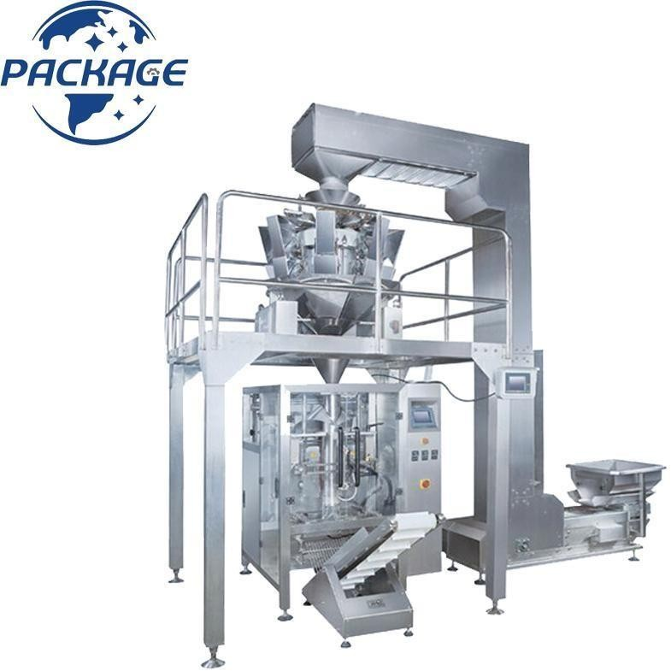

###### *Storage*

*Two people take packed boxes to the storage area. Storage*

*area is very clean and hygienic and Raj Wafers has a very large storage area.*

###### *Dispatch*

*Chips are dispatched by Trucks and Tempo in the local area and*

*through transports.*

###### *PLANT LOCATION CONSIDERING VARIOUS FACTORS* Plant location factors in general may begrouped under three heads:

1. *Regional factors*
2. *Community factors*
3. *Site factors*
4. *Regional factors: -*

*Decide the overall area within the country. Such factors are:* proximity to markets, proximity to sources of raw materials, availability of utilities, transport facilities, climatic condition, industrial and taxation laws, etc.

###### *Community factors: -*

*Community factors influence selection of the plant location* within the region. Such factors are: availability of labor, industrial and labor attitudes, social structure, service facilities, etc.

###### *Site factors: -*

*Site factors Flavors specific site within the community. Such* factors are: availability and cost of the land, suitability of the land, etc.

###### *Plan layout*

PANT LAYOUT

ENTRY

ENTRY

PROCESS AREA

SITTING AREA

OFFICE

AREA

PACKAGING AREA

FACTORY

STORE ROOM

WASH

ROOM

MAIN GATE

CAR PARKING

* 1. *MATERIAL HANDLING EQUIPMENT*

*“Material handling is defined as controlled movement of material, from receipts,* though storage and production and up to the shipment of finished product.”

*Raj wafers uses only solid raw material. Raj wafers* produces potato products so it does not produce higher weight age products. So, this is not using heavy material handling equipment crane, robots etc. but every machine is placed on its proper place so the work is very fast at time in that place. But when the company, orders the raw material, the raw material suppliers lay trucks. Tempos or any other vehicle.

*To unload the raw material from trucks man power is used when raw* material is turn into finished good it supplies to customer as a same usage.

###### *MATERIAL HANDLING*

*It is concerned with storage & internal movement of* following type of material handling.

###### *RAW MATERIAL*

*The potatoes brought from different place are stored in a room* having normal temperature so that they do not get damaged. Red potatoes and small size potatoes not used in making chips, so white big potatoes of special quality are ordered.

###### *WORK IN PROCESS*

*The work processed all are automatic by the machine at this stage. The* potato peelings are removed and they are used as manure in farms, but for that jute bag is used to gather the peeling and are transported to the farms.

###### *FINISHED GOODS MATERIAL HANDLING*

*After the wafer are made, they are packet in to plastic bags as* wholesaling to prevailing, packaging is done in kg. The store room has the normal room temperature where wafers are not damaged. If they are damaged, they are thrown off. Inspection is done now they sill it is sold by the worker. The packing material is to be discussed. The packing material is also to be included here. Plastic bags are used to pack the wafers. The ink which is used to do the printing is to be included. The drums are used to put the wafers after they are fried.

###### *EQUIPMENTS*

1. *PLATFORM TRUCK*

*The company uses the platform truck to transfer heavy potato bags* from raw material inventory to machine. The equipment uses men power. Worker moves the truck. Daily up, to it is the most useful thing.

###### *DRUMS*

*The company use the drums to transfer the finished potatoes chips* from machine to packing place. The drums transfer here or there by workers. After the wafers are ready, they are to be stored in the drums if they are not ordered for the parcel.

###### *PLASTIC BAG*

*Plastic bags are used or included in finished goods. When the wafers* are fried and completely ready to eat, they are to be packed in the plastic bags to serve to the customers. Big packs of specific kg are sold or transported in the plastic bags.

###### *INK*

*For the printing process, ink is used. To print the information of the* wafers, ink is needed. So, it is also included in the process of finished goods.

###### *TYPES OF INVENTORY CONTROL*

* *QUANTITATIVE CONTROLS:*

*Quantitative controls are concerned with planning, economic* ordering quantity, minimum stock level etc. it aims at preventing the costs of under or overstocking. The potatoes are brought from different places in different seasons to maintain quality in RAJ WAFERS.

###### *ACCOUNTING CONTROL:*

*Accounting aspect of control is concerned with maintain proper* books of accounts of the materials purchased and used. The main objective is to prevent theft and misuse of materials.

###### *ABC INVENTORY CONTROL SYSTEM*

*It is not desirable to keep the same degree of control on all* items. That is why to pay maximum attention to those items where value is the highest level. Therefore, the modern attention trend is to classify the inventory into three classes. All the precious items are placed in class C. such classification of inventory items into A, B and C groups is known as ABC analysis techniques of inventory control. In amusement it is also called “always better control.”

###### *INVENTORY MANAGEMENT TECHNIQUES*

*To manage inventories efficiently, answer should to the following two questions;*

###### *How much should be ordered?* When should it be ordered?

*The first question, how much to order, relates to the problem* of determining economic order quantity (EOQ), and is analysis of costs of maintaining certain levels of inventories.

###### *EOQ MODEL*

*One of the major inventory management problems to be resolved* is how much inventory should be added when inventory is replenished. If the firm is buying raw materials, it has to decided lots in which it has to be purchased on replenishment. If the firm is buying raw materials, it has to

*Decided lots in which it has to be purchased on replenishment.* Is planning a production run, the issue is how much production to schedule (or how much to make). These problems are called order quantity problems, and the task of the firm is to determine the optimum or economic order quantity.

*Economic ordering quantity means the quantity of purchasing* which is economically the most advantageous quantity. Such an economic ordering quantity should be worked out and every time as far as possible, the purchase order should be placed in economic ordering quantity. But the question is how to find out economic ordering quantity? It can be worked out taking into account two types of costs associated with inventory:

1. *Ordering cost*
2. *Carrying cost*

###### *STORAGE DEPARTMENT*

*In raj wafers they use store ledger and bin for store the* records. Store ledger is stock record which shows the receipts, consumption and balance of raw material both in quality and value store according. Bin card is maintained material received but awaiting inspection, name of suppliers, unit cost of items, cost of total inventory carried.

###### * *There is some daily function of storage department:*

1. *The quality of potatoes of raw material checks daily. The quantities of raw materials are checked.*
2. *They usage FIFO system for material issue and material is checked before issues.*
3. *Materials are issued against the material or store requisition.*
   1. MATERIAL RECEIPT PROCEDURE

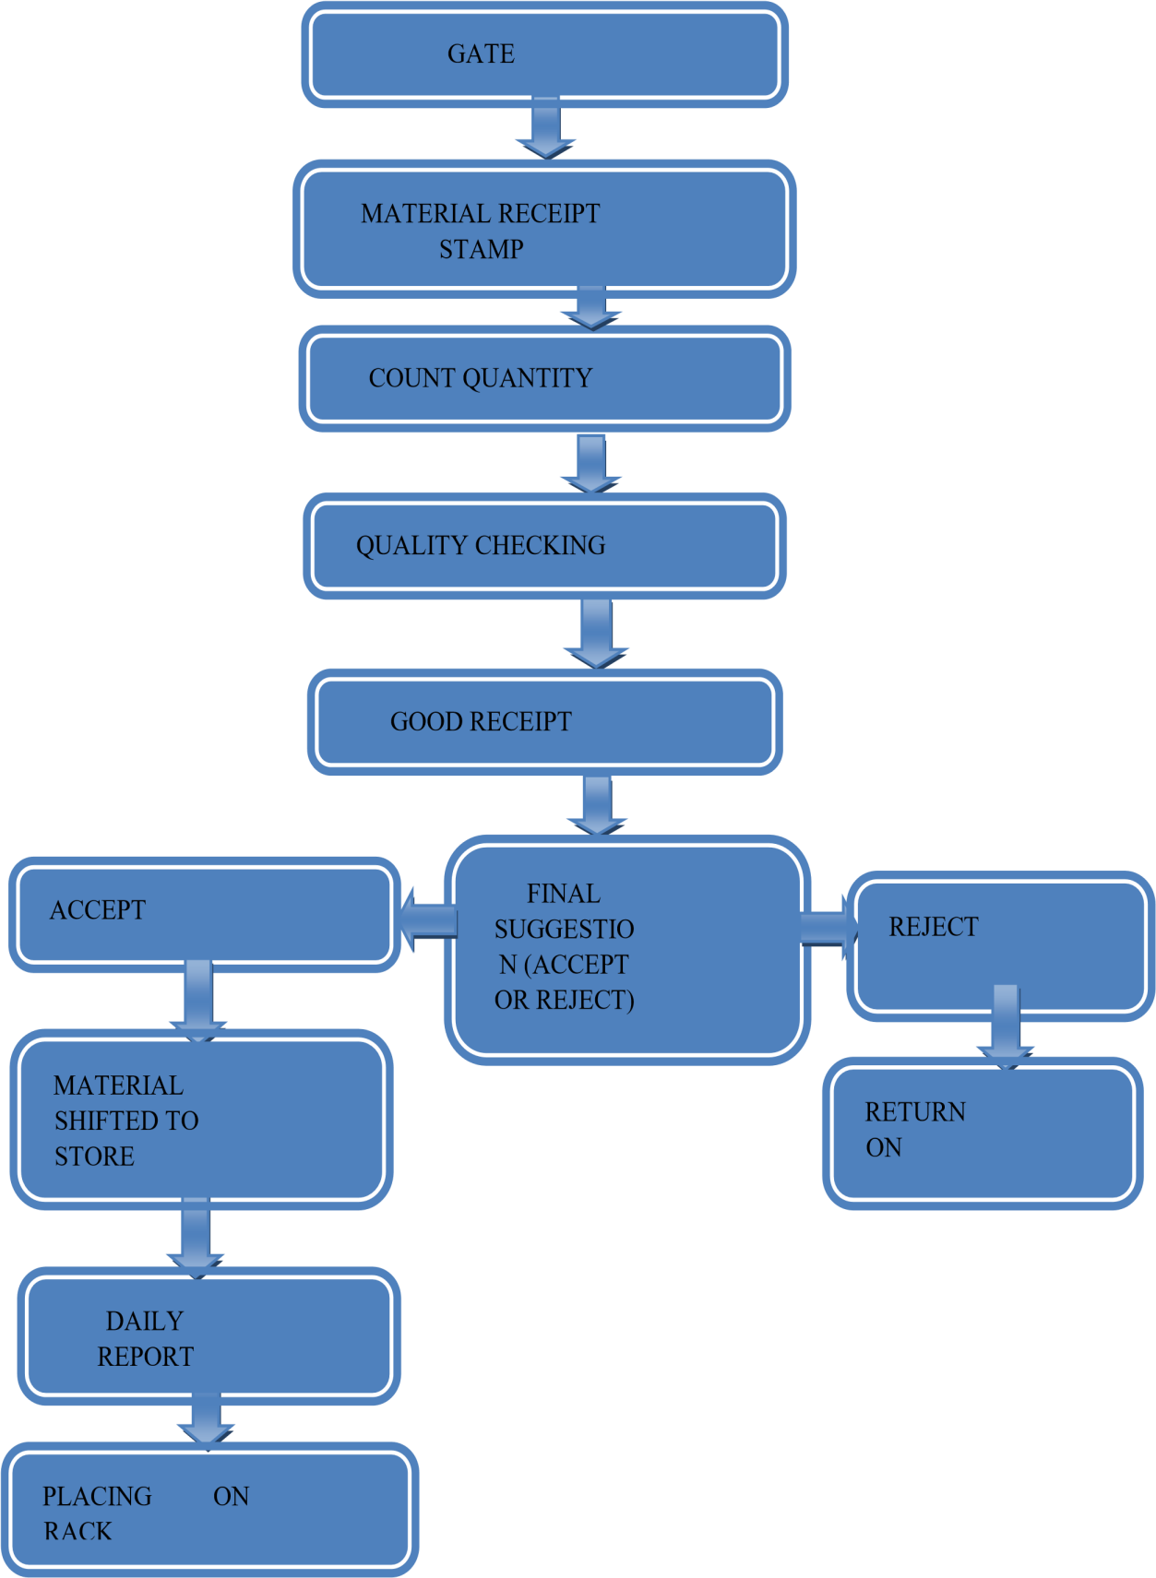

* 1. MATERIAL ISSUE PROCEDURE

Arrival of material at site via truck or



rail.

Unloading at ware house yard on

site.

Checked as to: nr. Of boxes, cover crates, Pieces etc.as shown on

delivery receipt.

Delivery receipt signed if in order.

Copy retained.

Freight collect charges if in order will be paid From petty cash.

Materials are checked as to: Quantity, quality, and specifications.

Material receipt notice (MRN) is prepared for each shipment.

In the event that materials received are not as per the order an "over,short

and damage report "is prepared.

* *An out-shipment is prepared to any material leaving site. Such shipments may require direct authorization from client.*
* *Materials not requiring indoor storage Placed at most convenient point for end use.*
* *Small fittings, bolts, baskets, valves, Instruments, materials will be stored in warehouse.*
* *All materials are checked on receipt for Proper protection. Pipe, is checked for color coding.*
* *Fittings and flanges are checked for color coding Valves are checked for proper tag no. (Metal label).*
* *All equipment is checked periodically until Turnover to construction or operators, to insure proper weather and corrosion Protection.*
* *Materials are issued to construction for Installation, upon receipt of a material Requisition.*
  1. *PLANNED MAINTANANCE*

*Breakdown of a machine or equipment does not occur in a* planned manner but maintenance work can be planned well in advance. Planned maintenance is also known as schedule maintenance or productive maintenance. It involves the inspection of all plant and equipment, machinery, according to a pre-determined schedule in order to service, lubricant or repair, before actual breakdown or deterioration in service occurs. It aims to reduce machine stoppage due to sudden break-downs necessitating emergency maintenance. RAJ WAFERS use and follows the chart of planned maintenance accordingly.

###### *PLANNING MAINTENANCE WORK*



PLANNING

CONTROLLING

SCHEDULING

RECORDING

EXECUTING

* 1. *QUALITY CONTROL SYSTEM*

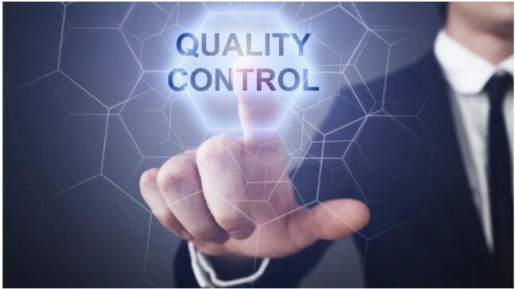

*“Quality control is a procedure intended ensure that a* manufactured product or performed service adheres to a define set of quality criteria or meets the requirement of the customer.” A process through which a

*business seeks to ensure that product quality is maintained or improved and* manufacturing errors are reduced or eliminated. Quality control emphasizes testing of products to uncover defects and reporting to management who make the decision to allow or deny product release.

*Whereas quality assurance attempts to improve and stabilize* production to avoid, or at least minimize, issues which led to the in the first place. For contract work, particularly work awarded by government agencies, quality control issues are among the top reasons for not renewing a contract. Firstly, at the previous stage, the potatoes are finally observed and then purchases. So, the quality of the potatoes is maintained here. At the second stage the potatoes are qualified automatically by the machines. At the third stage, after the chips are made, they are stored at perfect type store room with the temperature suitable to it. So, the policy of ensuring the quality is followed. Raj wafers checks the quality of all three types of products, raw material, in process goods and finished product.

###### *QUALITY CONTROL USES:*

* *RAW MATERIAL:*

*In this stage, raw materials are being checked and compare with* specified quality or order placed. In quality control, they check the quality of raw material. If quality of raw materials is not satisfactory, good will gets rejected. If acceptable report is sent to store department. Raw material is brought from different place in different seasons according to price and availability.

###### *WORK IN PROCESS GOODS: -*

*Raj wafers also check the quality of goods during the process of* production so it there any problems in quality while processing, it can remove by talking corrective action and make qualitative product for customer. These types of checking record are kept in “slandered verification.”

###### *FINISHED PRODUCT:*

*When product is finished the process the them some samples are* send to quality control department for quality checking and if quality checking and if quality is accepted than only finished product give to packing department for packing and labelling. The document is used or keeps this type of records is called: finished product report.

# *CHAPTER 3 MARKETING DEPARTMENT*



###### *Introduction of marketing*

* *Objective of marketing department*
* *Organization structure of marketing department*
* *Customer segmentation and target marketing*
* *List of products*
* *Sales procedure*
* *Order processing system*
* *Philosophy of marketing*
* *Distribution channel*
* *Activity of distribution*
* *Product life cycle and its marketing strategy*
* *Packaging & labelling of raj wafer*
* *4 p’s of raj wafer: -*

1. *Product*
2. *Price*
3. *Promotion*
4. *Place*
   1. ***INTRODUCTION MARKETING***

*Marketing is communicating the value of a product, service or* brand to customers, for the purpose of promoting or selling that product, service, or brand. The main purpose is to increase sales of the product and profits of the company. Marketing acts a support system to the sales team by propagating the message and information to the target audience.

*Marketing techniques include choosing target market through* market analysis and market segmentation, as well as understanding consumer behavior and advertising a product’s value to the customer.

* 1. ***OBJECTIVES OF MARKETING DEPARTMENT:***
* *Increase sales*
* *Build brand awareness*
* *Grow market share*
* *Launch new product*
* *Target new customer*
* *Enhance customer relationship*
* *Increase profit*

#### *ORGANISATION STRUCTURE OF MARKETING DEPARTMENT*

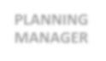

**MARKETING**

**PRESIDENT**

**PLANNING**

**MANAGER**

**BRAND**

**SUPERVISOR**

**PLANNING**

**SUPERVISOR**

**BRAND**

**SUPERVISOR**

**STAFF**

**STAFF**

**STAFF**

**STAFF**

* 1. ***CUSTOMER SEGMENTATION***

###### *Consumer market segmentation*

* 1. *Geographic*
* *Country-England, UK, Europe*
* *Urban Or Rural- Measured by the Area’s Population Destiny*
* *City – New York, Chicago*
* *Region the Country- North India, West India, South India*
  1. *Demographic:*
* *Age Group – Teens, Young Adults, Older Adults*
* *Occupation- Professional, Trade, Unskilled Religion – Hindu, Muslim, Christian*
* *Gender – Male, Female*
* *Education – High School, University Marital Status - Married, Single*
  1. *Psychographic:*
* *Social Class – Upper Class, Middle Class, Lower Class*
* *Lifestyle Type – Family, Social Education*
* *Personality Type – Ongoing, Creative, Serious*
  1. *Behavioral:*
* *Product Usage – Light, Medium, Heavy Users*
* *Brand Loyalty – None, Medium, High*
* *Type Of User – With Meal, Special Occasions*
  1. *Benefits Sought:*
* *Needs/Motivation – Value, Safety*

###### *Industrial Market Segmentation*

1. *Geographic Location :*

* *Country*
* *Region*
* *Number Of Outlets*

1. *Business Description :*

* *Industry*
* *Size*
* *Product Sold*
* *Equipment*

1. *Culture/Personality :*

*Raj Wafers Make Segments by Geographic Variables.* Geographic Variables Such as Region, City, Climate Etc. Company Select Western India 16 BRCM COLLAGE OF BUSINESS ADMINISTRATION Region for Its Product and Surat City for Production. Demographic Variables Are Gender, Age, Income; Education Etc. Wafers Are Eaten by All Kind of Age Groups, Whether They Are Small, Young or Old.

#### *TARGET MARKET*



*A target market is a group of customers towards which a* business has decided to aim its marketing efforts and ultimately its merchandise. A well- defined target market is the first element to a marketing strategy. The marketing mix variables of product, place (distribution), promotion and price are

*the four elements of a marketing mix strategy that determine the success of a* product in the markets place. Target markets are groups of individuals that are separated by the following aspects:

* 1. *Demographic:*
* *Gender*
* *Age*
* *Income*
* *Occupation*
* *Education*
  1. *Psychographic:*
* *Attitude*
* *Values*
* *Lifestyle*
  1. *Behavior:*
* *Occasion*
* *Degree of loyalty*

###### *POSITIONING*

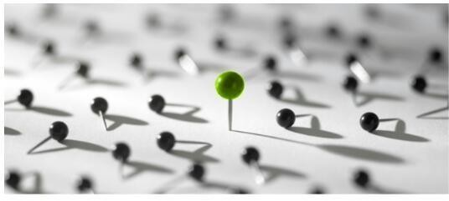

*‘Positioning is act of designing company’s offering and image* to occupy distinctive place in the mind of the target market. For example: - Domino's pizza positioned as promised delivering pizza within 30 minutes plays a differentiating role for the brand.’ An effort to influence consumer perception of a brand or product relative to the perception of competing brands or products. Its objective is to occupy a clear, unique, and advantageous position in the customer’s mind. There are three types of positioning concepts:

###### *Functional position:*

* *Solve problems*
* *Provide benefits to customers*
* *Get favorable perception by investors and lenders*

*Symbolic positions:*

* *Self-image enhancement*
* *Ego identification*
* *Belongingness and social meaningfulness*
* *Affective fulfilment*

*Experiential positions:*

* *Provide sensory stimulation*
* *Provide cognitive stimulation*
* *Raj wafers is positioned at*

#### *“HEALTY FOOD…HEALTHY LIFE…”*

* 1. ***SALES PROCEDURE***

*The sales procedure of raj wafers. It starts with order placing* and ends with placing the product according to the need of the customer. The customer of raj wafers. Are mainly dealer and institutional and organized sectors.

* *They follow the following sales procedure: -*
* *Inform to marketing manager*

*The factory located at Surat send letter to the marketing* department showing that the ready according to the purchase order placed by customer.

* *Inform to customer*

*The marketing department inform customer through telephone or*

*telegraph.*

* *Adjustment for delivery*

*According to that information, marketing department adjust the* delivery time and inform the production department.

* *Sending goods*

*Production department send goods according to the marketing*

*department.*

* *Confirm to customer*

*Marketing department confirm to customer whether the goods* is received and placed.

#### *ORDER PROCESSING SYSTEM*

*Without customer organization can’t send goods or products to customer.*

1. *Order acceptance*

*After receiving order, marketing department send a letter to the*

*production department named “order acceptance cum works order.”*

1. *Confirmation letter*

*Production department confirm and send confirmation letter to* marketing department.

1. *Adjust order*

*Production department adjust order according to the quantity.*

* + *Informs to marketing department*

*After producing the products according to order placed,* production department inform marketing department.

* + *Dispatch the goods*

*According to the requirement of the marketing department,* production department dispatch the goods.

* + *Send the invoice*

*And lastly, marketing department send the invoice.*

#### *PHILOSOPHY OF MARKETING*

*Under the marketing management philosophy, we have studied the* following five concepts: -

1. *production concept*
2. *product concept*
3. *selling concept*
4. *marketing concept*
5. *societal marketing concept*

*RAJ WAFER is using marketing concept. Raj wafers believes in* marketing concept with the fact that success can be achieved only through consumer satisfaction. The basis of this thinking is that only those products should be made available which the consumers wants or desires to.

*In other words, they do not sell what they can make but they* make what they can sell. Keeping in mind this idea; it directs their marketing efforts to achieve consumer satisfaction.

*In short, it can be said that it is a modern concept and by* adopting it profit can be earned on a long-term basis. The drawback of this concept is that no attention is paid to social welfare.

#### *DISTRIBUTION CHANNEL*

*Distribution net-work can be defined as set of interdependent* institution participating in the marketing activities involved in the flow of goods and services from manufacture to customer. Raj wafers has developed distribution network for marketing activities. Raj wafers has own distribution network. In, Surat, Bharuch, Ankleshwar, Baroda, Ahmadabad, Visnagar, Mehsana, Randeja, Kukarwada, Sidhdhapur and also in Rajasthan and Maharashtra.

* 1. *ZERO LEVEL*

*Zero level channel means there is no intermediary between the* company and the consumer. It is called ad direct marketing can be done with help of personal selling, direct mail, telephone selling and internet. The products are sent directly to customers by the manufactures.



MANUFACTURING

CONSUMER

* 1. *ONE LEVEL*

*One level channel contains one selling intermediary. In such a*

*channel manufacturer will supply their product directly to one element of* retailers. These MANUFACTURING CONSUMER retailers are selling the good to the customers. In some cases, in order to remain profitable and reputed retailers the manufactures act as wholesalers. One of the advantages for the intermediaries is the discounts they receive.



MANUFACTURE

RETAILER

CONSUMER

*2. TWO LEVEL*

*Two level channels contain three selling intermediaries. In this*

*channel manufacture will produce the goods to distributor, then pass to* wholesalers, then to retailers, then pass to customers. The agent contacts wholesalers and received commission on sales.



MANUFACTURE

WHOLESALER

RETAILOR

CONSUMER

#### *ACTIVITIES OF DISTRIBUTION*

1. *Transportation*

*RAJ WAFERS user their own vehicles for transportation. They use* truck for transportation on road ways.

1. *Services*

*Services are intangible and in substantial not be touched gripped,* handled, looked at, smelled, and tasted. Thus, there is neither potential nor need for transport, storage or stocking of services. RAJ WAFERS give the services of the transportation. Company changes the product if there is any damage in transportation.

1. *Margins of channel partner*

*RAJ WAFERS give 20% margin to their dealer.*

1. *after sales service*

*If the product has reached the dealer in damaged condition the* company gives them the fresh stock.

#### *PRODUCT LIFE CYCLE & ITS MARKETING*

*A product life cycle is meaning a typical pattern of development* of life time sales of product. A product life cycle can be defined as a history of time sale of a product from the stage of its introduction to the stage of its decline.

*As very being has life, a product has its life. Industrial goods* may have a longer life than consumer goods. When a product idea is commercialized, the product enters into the market and competes with the rivals for making sales and earning profits. Products, like human beings have length of life. This has been described as life cycle in human beings and when applied to products, it called as product life cycle. PLC deals with the life of a product in the market with respect to business or commercial cost and sale measures.

*Product life cycle is a business analysis that attempts to* identify a set of common stages in the life of commercial products. In other words, Product life cycle (PLC) is used to map the lifespan of the product such as the stages through which the product goes during its lifespan. During its whole life a product passes through different stages, which is known as product life cycle. The stages of PLC:

* *Introduction*
* *Growth*
* *Maturity*
* *Decline*

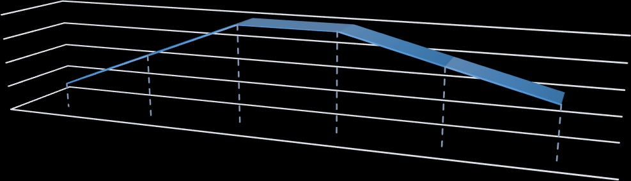

**SA**

**LE S**

**PRODUCT LIFE CYCLE**

8

**IN** 6

**VO** 4

**LU** 2

**M** 0

GROWTH

GROWTH

MATURITY

MATURITY

DECLINE

DECLINE

**TIME**

|  |  |  |  |  |  |  |
| --- | --- | --- | --- | --- | --- | --- |
|  | GROWTH | GROWTH | MATURITY | MATURITY | DECLINE | DECLINE |
| PRODUCT LIFE CYCLE | 2 | 5 | 8 | 8 | 6 | 4 |

1. *Introduction stage:*

*This stage of the cycle could be the most expensive for a* company launching a new product. The size of the market for the product is small, which means sales are low, although they will be increasing. In other hand, the cost of things like research and development, consumer testing, and the marketing needed to launch the product can be very high, especially if it’s a competitive sector.

1. *Growth Stage:*

*The growth stage is typically characterized by a strong* growth in sales and profits, and because the company can start to benefit from economies of scale in production, the profit margins, as well as the overall amount of profit, will increase. This makes it possible for businesses to invest more money in the promotional activity to maximize the potential of this growth stage.

1. *Maturity Stage:*

*During the maturity stage, the product is established* and the aim for the manufacturer is now to maintain the market share they have built up. This is probably the most competitive time for most products and businesses need to invest wisely in any marketing they undertake. They also need to consider any product modifications or improvements to the production process which might give them a competitive advantage.

1. *Decline Stage:*

*Eventually, the market for a product will start to shrink,* and this is what’s known as the decline stage. This shrinkage could be due to the market becoming saturated (i.e., all the customers who will buy the product have already purchased it), or because the consumers are switching to a different type of product. While this decline may be inevitable, it may still be possible for companies to make some profit by switching to less-expensive production methods and cheaper markets.

* 1. **Packaging & labelling of raj wafer**

###### *PACKAGING OF RAJ WAFERS*

*The packaging of a consumer product is an important part of* the marketing plan. There are many factors to be considered while designing a package. Packaging means wrapping of goods before they are transported or store or delivered to a consumer. RAJ WAFERS have very nice packaging wrapper of plastic bag.

*"Packaging is the science, art and technology of enclosing or* protecting products for distribution, storage, sale, and use".

###### *LABELLING OF RAJ WAFERS*

*“Label is a part of product, which carries verbal information about the product* or the seller. It may be a part of package, or it may be a tag attached directly to the product".

*Label may be a small slip or it may be an attached of the* product. It conveys verbal information about the product and seller. The producer gives necessary information to the consumer through the label. The act of attaching or tagging the label is known as labelling.

* *The following information is available on the label of wafers:*
* *Company name*
* *100% vegetarian trade mark symbol*
* *Max. Retail price (inclusive of all taxes)*
* *Net weight*
* *Batch no.*
* *Packing date*
* *Manufactured by*
* *Company address*
* *Ingredients*
* *Barcode sticker*
* *It is a tool of promotion*
* *Brand related information*
* *Feedback and customer care information & contact no.*
* *Nutritional values*
  1. 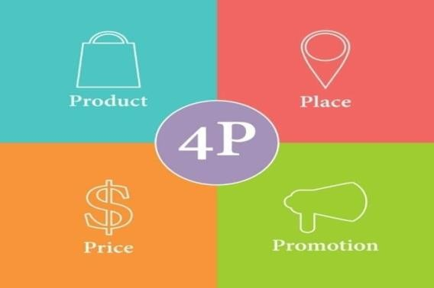***4 Ps of RAJ WAFERS***

###### *PRODUCT*

*According to Philip Kotler, “A product is anything that can be*

*offered to a market for attention, acquisition, use or consumption that might* satisfy a want or need. It includes physical objects, services, persons, places, organization and ideas.”

*Established markets generate intense competition during which* new and innovative marketing strategies are required and new and existing products are developed. A product is something that is viewed as capable of satisfying a human need.

* + *PRODUCT MIX OF RAJ WAFERS:*

*“A product mixes the set of all product lines and items that a* particular seller offers for sale to buyers.” It has four main characteristics:

1. *Length*

*The length of a company's product mix pertains to the total* number of products the company sales, for example, a RAJ WAFERS company may have three product lines: Chips, Farali chevdo, and Salli. This consumer product company may sell two snack items, three items of farali chevdoand three varieties of Salli. Therefore, the company product mix length is 8.

1. *Width*

*The width of product mix includes all the product lines that a*

*company sells. For example, if a RAJ WAFERS company sells various products like* chips, farali chevdo, and Salli. Its product width is 3.

1. *Depth*

*A company's product mix depth pertains to the total number of*

*variations for each product. Product variation can include flavor, fragrance, and* size. For example, if a RAJ WAFERS company sells three products. There are two depths in clips, three depths in farali chevdo, and three depths in Salli.

1. *Consistency*

*Consistency of product mix refers to the relationship between* product line, including use production and distribution. For example, RAJ WAFERS Company may use similar production line for several different type of chips, faralichevdo, and Salli. The product mix refers to how closely the various product lines are related in production.

###### *PRICE*



*Pricing is a crucial matter for the marketing manager because* it affects the demand, sales promotion, competitive strength of the business unit and ultimately the profits. The marked or announced amount of money asked from a buyer is known as basic price of a product. RAJ WAFERS uses value pricing

*method for its products. In this method, company is charging fairly low price for* highly qualitative product, which its competitor can't do. To the consumer the price is an agreement between seller and buyer concerning what each is to receive.

*“Price is the exchange value for the product values for the product or service.* This exchange value may be in terms of money or in terms or in terms of product or service.”

*Price = All cost + Attributes*

###### *OBJECTIVES OF PRICING: -*

* *Maximize Profit*

*Maximize your profits by balancing the price of your goods with* anticipated demand. Charts the demand for your products at various price points. Select price at which your supply and demand intersect. Consider your overall profit at various supply levels and increase or decrease your supply based on revenue projection.

###### *Enhance promotion: -*

*Price your goods to enhance a marketing campaign. You can lower* price through coupons, special offers and discount. These promotions encourage customers to purchase more products, try a new product or change brands. Common pricing strategies include bulk discounts, seasonal promotions and customer-loyalty discounts. Price discounts help increase sales to price-sensitive consumers and increase the value proposition of your products or services. Discount in RAJ WAFERS are high in the "Shrawan" period due to fast of many people.

###### *Cost recovery: -*

*Recover the cost of your product investment. Heavily discount* you to move older goods when changing product designs or when terminating a

*product. Lowering your price may not result in profits, but you can decrease your* storage overhead and make distribution channels available for new products of services, Labour and manufacturing costs. You can also use a cost recovery pricing strategy if your company needs rapid cash flow returns.

###### *Competitive leadership: -*

*Create a price strategy to establish your company's leadership* position in the market. Selling products below cost can be a short-term measure to reduce your competition, increase your market share and penetrate tough market. You can also 29 BRCM COLLAGE OF BUSINESS ADMINISTRATION

*establish your product as the luxury leader by pricing your products at a* premium. Match your pricing strategy to your market leadership objectives for maximum impact.

* *Distinguish product: -*

*Set your prices to distinguish items in multiple product lines. Use* piece to establish quality differences and prestige perception. Pricing differences can also distinguish your products from your competitors. Higher prices tend to denote higher quality or more desirable products, while lower prices can denote an economical product selection.

* + *METHODS OF PRICING: -*
* *Cost plus pricing*
* *Pricing based on breakeven point*
* *Pricing based on marginal cost.*

###### *PLACE: -*

*Marketing channel is the series of ways or activities needed to*

*transfer the ownership of goods, and to move goods, from the point of* production to the point of consumption. Place means the decision by which company transfers their product, location, inventory handling, warehousing, storage facility, transportation etc. RAJ WAFERS near the high way so it can

*transport and get material easily. RAJ WAFERS has own wholesaler customers in* various cities so it can easily provide products to them than its competitors.

*“Distribution channel refers to the set of marketing institutions* participating in marketing activities involved in the flow of goods or services from the primary producers to ultimate consumer.”

###### *PROMOTION: -*

*Promotion is any communicative activity whose main objects is to* move forward a product, service or an idea in a channel of distribution. Discount and selling the products at low price is normally observed in Shrawan month. The fast 30 BRCM COLLAGE OF BUSINESS ADMINISTRATION having people are given some free eatables by the company as the also prepares their special types of eatables only consumed in fasts.

*“Promotion is to communicate with individuals, groups or* organization to directly or indirectly facilitate exchanges by informing and persuading one or more audiences to accept and organization product.”

###### *PROMOTION MIX: -*



ADVERTISING

DIRECT MARKETING

SALES PROMOTION

PROMOTION MIX

PUBLIC RELATION

PERSONAL SELLING

*“Promotion mix is the combination of one or more of the communication tools* used to inform, persuade, or remind prospective buyers.”

1. *Price:*

*They decide to provide product at fair price every person can afford*

*it.*

1. *Advertising: activities.*

*RAJ WAFERS does not use advertising and less use promotional*

1. *Publication:*

*RAJ WAFERS does promotion by public relation. RAJ WAFERS* makes aware people about its product by public relation. Public relation is informal channel of marking.

1. *Dealer network:*

*RAJ WAFERs have well developed dealer network in Gujarat* which play important role for RAJ WAFERs becomes popular in Gujarat and its near states because of its high qualitative products and fairly low prices than others.

1. *Corporate image:*

*It is an important to create a good image in the sight of general* public as the image of an organization is a crucial in marketing.

* + *DISCOUNT AND ALLOWANCES*

*As there is no discount and allowances.*

* + *TAXES*

*Taxes is not applicable because there are doing loose retail it*

*means that they are selling huge packaging.*

# *Chapter 4 FINANCE DEPARTMENT*

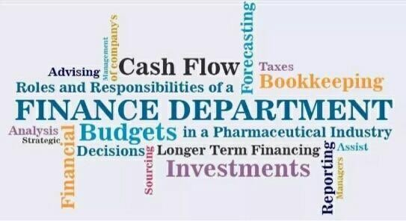

#### *4.1 INTRODUCTION OF FINANCE DEPARTMENT*

*Finance is an important consideration for both individuals* and organizations. On a personal level, financial well-being enables people to purchase goods and services, either as needs or wants. For businesses, governments and other large organizations, healthy finance is vital or survival and success. Till 1950, finance function was regarded as the function only of raising fund for business, and consequently the discussion cantered round different sources of finance, financial documents, etc. since last 3o-4o years, however, an effective and efficient utilization of finance has also been considering as an important function of financial management.

*“A discipline concerned with determining value and making* decision. The finance function allocates resources, including the acquiring, investing and managing of resources.”

#### *IMPORTANCE OF FINANCE:*

* *Prepare and create financial accounts: Such as trading, profit and loss account*

*and the balance sheet.*

* *Keep and maintain financial records: Sales figures and records of expenditure*

*would be held by the finance department and used by other departments also.*

* *Prepare and plan internal financial information: this Would mainly be performed in the case of a budget, which is a financial plan and can help manager take corrective action.*
* *Pay creditors: Finance department would ensure that bills are paid to people the firm owes money to.*

###### *TREND OF WORKING CAPITAL MANAGEMENT IN RAJ WAFERS*

|  |  |  |
| --- | --- | --- |
| **PARTICULAR** | **2021** | **2022** |
| **CURRENT ASSETS** | | |
| Inventories | 1535.33 | 254.76 |
| Cash and bank balance | 2357.91 | 2650.98 |
| Short -term loans and advances | 882.42 | 1213.25 |
| Other current assets | 1688.21 | 2319.34 |
| **TOTAL CURRENT ASSETS(A)** | **6463.87** | **8438.33** |
| **CURRENT LIABLITIES** | | |
| Short term borrowings | 223.74 | 0.00 |
| Trade payables | 3103.76 | 3974.83 |
| Other current liabilities | 4208.12 | 4047.54 |
| Short term provisions | 1435.28 | 1448.96 |
| **TOTAL CURRENT LIABILITIES(B)** | **8970.9** | **9471.33** |
| **NET WORKING CAPITAL(A-B)** | **(2507.03)** | **(1033)** |

* SCHEDULE OF WORKING CAPITAL

|  |  |  |  |  |
| --- | --- | --- | --- | --- |
| **PARTICULAR** | **2021** | **2022** | **INCRE ASE IN W.C** | **DEC REAS E IN W.C** |
| **A)ESTIMATI ON CURRENT ASSETS** | | | | |

|  |  |  |  |  |
| --- | --- | --- | --- | --- |
| Inventories | 1535.33 | 2254.76 | 719.43 | - |
| Cash and bank balance | 2357.91 | 2650.98 | 293.07 | - |
| Short -term loans and advances | 882.42 | 1213.25 | 330.83 | - |
| Other current assets | 1688.21 | 2319.34 | 631.13 | - |
| **TOTAL CURRENT ASSETS(A)** | **6463.87** | **8438.33** | **-** | **-** |
| **LESS(-)** | | | | |
| **B) ESTIMATION CURRENT LIABLITIES** | | | | |
| Short term borrowing | 223.74 | 0.00 | 223.74 | - |
| Trade payables | 3103.76 | 3974.83 | - | 871.0  7 |
| Other current liabilities | 4208.12 | 4047.54 | 160.58 | - |
| Short term provisions | 1435.28 | 1448.96 | - | 13.68 |
| **TOTAL CURRENT LIABILITIES( B)** | **8970.9** | **9471.33** | **-** | **-** |
| **NET WORKING CAPITAL(A- B)** | **(2507.03)** | **(1033)** | **2358.78** | **884.7**  **5** |
| **INCREASE IN WORKING CAPITAL** | **-** | **1474.03** | **-** | **1474.**  **0** |
| **TOTAL** | **2507.03** | **2507.03** | **2358.78** |  |

* + PROFIT AND LOSS ACCOUNT

RAJ WEFARS PVT LTD PROFIT&LOSS ACCOUNT AS AT 31ST MARCH, 2017-18

(TREND ANALYSIS)

|  |  |  |  |  |
| --- | --- | --- | --- | --- |
| **TREND ANALYSIS** | | | | |
| **PARTICULAR** | **2021** | **2022** | **2021** | **2022** |
| **Gross profit** | **48195.29** | **58274.89** | **100** | **120.91%** |
| **Less: excise** | **672.60** | **766.96** | **100** | **114.03%** |
| **Net sales** | **47522.69** | **57507.93** | **100** | **121.01%** |
| **Raw materials consumed** | **36365.67** | **46077.85** | **100** | **126.70%** |
| **Power &fuel cost** | **1243.1** | **1675.5** | **100** | **134.78%** |
| **Employee cost** | **782.3** | **843.5** | **100** | **107.82%** |
| **Other manufacturing expenses** | **1376.29** | **1299.51** | **100** | **-94.42%** |
| **Administration expenses** | **555.63** | **665.14** | **100** | **119.71%** |
| **Selling & distribution expenses** | **152.08** | **148.07** | **100** | **-97.36%** |
| **Miscellaneous expenses** | **710.86** | **768.07** | **100** | **108.04%** |
| **Expenses capitalized** | **-25.24** | **15.02** | **100** | **-59.50%** |
| **Total expenditure** | **41162.9** | **50826.75** | **100** | **123.47%** |
| **PBIDT** | **6359.79** | **6681.18** | **100** | **105.05%** |
| **Other income** | **873.94** | **919.38** | **100** | **105.19%** |
| **Operating profit** | **7233.73** | **7600.56** | **100** | **105.07%** |
| **Interest** | **195.02** | **366.19** | **100** | **187.77%** |
| **PBDT** | **7038.71** | **7234.37** | **100** | **102.77%** |

|  |  |  |  |  |
| --- | --- | --- | --- | --- |
| **Depreciation** | **980.94** | **1176.15** | **100** | **119.9%** |
| **Profit before tax & exceptional items** | **6057.77** | **6058.22** | **100** | **100%** |
| **Exceptional income** | **0.00** | **344.1** | **100** | **00%** |
| **Profit before tax(PBT)** | **6057.77** | **6402.32** | **100** | **105.68%** |
| **Provision for tax** | **2035.7** | **2027.05** | **100** | **-99.57%** |
| **Profit after tax(PAT)** | **4022.20** | **4375.27** | **100** | **108.77%** |

PROFIT AND LOSS ACCOUNT

RAJ WEFARS PVT LTD PROFIT&LOSS ACCOUNT

AS AT 31ST MARCH, 2021-2022

(COMMON SIZE)

|  |  |  |  |  |
| --- | --- | --- | --- | --- |
| **COMMON SIZE** | | | | |
| **PARTICULAR** | **2021** | **2022** | **2021** | **2022** |
| **Gross profit** | **48195.29** | **58274.89** | **101%** | **101.33%** |
| **Less: excise** | **672.6** | **766.96** | **1.41%** | **1.33%** |
| **Net sales** | **47522.69** | **57507.93** | **100%** | **100%** |
| **Raw materials consumed** | **36365.57** | **46077.85** | **76.52%** | **80.12%** |
| **Power &fuel cost** | **1243.1** | **1675.5** | **2.61%** | **2.91%** |
| **Employee cost** | **782.3** | **843.5** | **1.65%** | **1.46%** |
| **Other manufacturing expenses** | **1376.29** | **1299.51** | **2.89%** | **2.26%** |

|  |  |  |  |  |
| --- | --- | --- | --- | --- |
| **Administration expenses** | **555.63** | **665.14** | **1.17%** | **1.26%** |
| **Selling &**  **distribution expenses** | **152.08** | **148.07** | **0.32%** | **0.25%** |
| **Miscellaneous** | **710.86** | **768.07** | **1.49%** | **1.33%** |

|  |  |  |  |  |
| --- | --- | --- | --- | --- |
| **expenses** | | | | |
| **Expenses capitalized** | **-25.24** | **15.02** | **-0.05%** | **0.03%** |
| **Total expenditure** | **41162.90** | **50826.75** | **86.61%** | **88.38%** |
| **PBIDT** | **6359.75** | **6681.18** | **13.38%** | **11.61%** |
| **Other income** | **873.94** | **919.38** | **1.83%** | **1.59%** |
| **Operating profit** | **7233.73** | **7600.56** | **15.22%** | **30.22%** |
| **Interest** | **195.02** | **366.19** | **0.41%** | **0.64%** |
| **PBDT** | **7038.71** | **7234.37** | **14.81%** | **12.58%** |
| **Depreciation** | **980.94** | **1176.15** | **2.06%** | **2.04%** |
| **Profit before tax &**  **exceptional**  **items** | **6057.77** | **6058.22** | **12.74%** | **10.53%** |
| **Exceptional income** | **0.00** | **344.10** | **0.00%** | **0.59%** |
| **Profit before tax(PBT)** | **6057.77** | **6402.32** | **12.74%** | **11.13%** |
| **Provision for tax** | **2035.7** | **2027.05** | **0.42%** | **3.52%** |
| **Profit after tax(PAT)** | **4022.20** | **4375.27** | **8.46%** | **7.60%** |

* + - BALANCE SHEET

(COMMON SIZE)

RAJ WEFARS PVT LTD BALANCE SHEET AS AT 31ST MARCH, 2021-2022

|  |  |  |  |  |
| --- | --- | --- | --- | --- |
| **BALANCE SHEET** |  |  | **COMMAN SIZED** | |
| **PARTICULAR** | **2021** | **2022** | **2021** | **2022** |
| **CURRENT LIABILITIES** | | | | |
| **Share capital** | **1268.48** | **1268.48** | **2.66%** | **2.38%** |
| **Total reserves** | **22959.32** | **25803.85** | **48.16%** | **4853%** |
| **Share holder’s**  **funds** | **24227.80** | **27072.33** | **50.83%** | **50.91%** |
| **Secured loans** | **3479.75** | **4051.00** | **7.30%** | **7.61%** |
| **unsecured loans** | **4661.03** | **5475.09** | **9.71%** | **10.20%** |
| **deferred tax assets/liabilities** | **2300.06** | **2566.37** | **4.82%** | **4.82%** |
| **Long term liabilities** | **685.07** | **771.17** | **1.44%** | **1.45%** |
| **Long term provision** | **3340.25** | **3761.62** | **7%** | **7.07%** |
| **Total noncurrent liabilities** | **14466.16** | **16625.25** | **30.35%** | **31.26%** |
| **Trade payable** | **3103.76** | **3974.83** | **6.51%** | **7.47%** |
| **Other current liabilities** | **4208.12** | **4047.54** | **8.83%** | **7.61%** |
| **Short term borrowing** | **273.74** | **0.00** | **0.47%** | **0.00%** |

|  |  |  |  |  |
| --- | --- | --- | --- | --- |
| **Short term provision** | **1453.28** | **1448.96** | **3.01%** | **2.72%** |
| **Total** | **8970.920** | **9471.33** | **18.82%** | **17.81%** |
| **Total current liabilities** | **47664.86** | **53168.91** | **100.00% 100.00%** | |
| **CURRENT ASSETS:** | | | | |
| **Gross block** | **31148.97** | **34056.32** | **65.35%** | **64.05%** |
| **Less: accumulated Depreciation** | **11439.09** | **12571.62** | **23.99%** | **0.24%** |
| **Less: impairment of assts** | **2.51** | **8.07** | **0.01%** | **0.01%** |
| **Net block** | **19707.45** | **21476.63** | **41.35%** | **40.39%** |
| **Less: adjustment A/C** | **8977.82** | **9727.85** | **18.83%** | **18.29%** |
| **Noncurrent investment** | **3680.05** | **4103.00** | **7.72%** | **7.71%** |
| **Long term and advance** | **6171.61** | **6544.8** | **12.94%** | **12.30%** |
| **Other noncurrent assets** | **73.74** | **66.31** | **0.15%** | **0.12%** |
| **Total noncurrent assets** | **38610.67** | **41918.54** | **81.00%** | **78.84%** |
| **Investment** | **39.95** | **0.00** | **8.00%** | **0.00%** |
| **Inventory** | **1535.33** | **2254.76** | **3.22%** | **4.24%** |
| **Sundry debtors** | **2551.34** | **2811.99** | **5.35%** | **5.28%** |
| **Cash and bank balance** | **2357.91** | **2650.98** | **4.94%** | **4.98%** |
| **Other current assets** | **1688.21** | **2319.34** | **3.54%** | **4.36%** |

|  |  |  |  |  |
| --- | --- | --- | --- | --- |
| **Short terms loans advance** | **882.42** | **1213.25** | **1.85%** | **2.28%** |
| **Total noncurrent assets** | **9054.19** | **1125.32** | **18.99%** | **21.15%** |
| **Total current assets** | **47664.86** | **53.168.91** | **100.00%** | **100.00%** |

* BALANCE SHEET

RAJ WEFARS PVT LTD BALANCE SHEET AS AT 31ST MARCH, 2017-18

(TREND ANALYSIS)

|  |  |  |  |  |
| --- | --- | --- | --- | --- |
| **BALANCE SHEET** |  |  | **TREND ANALYSIS** | |
| **PARTICULAR** | **2021** | **2022** | **2021** | **2022** |
| **CURRENT LIABILITIES** | | | | |
| **Share capital** | **1268.48** | **1268.48** | **100%** | **100%** |
| **Total reserves** | **22959.32** | **25803.85** | **100%** | **112.39%** |
| **Share holder’s**  **funds** | **24227.80** | **27072.33** | **100%** | **111.74%** |
| **Secured loans** | **3479.75** | **4051.00** | **100%** | **116.41%** |
| **unsecured loans** | **4661.03** | **5475.09** | **100%** | **117.47%** |
| **deferred tax assets/liabilities** | **2300.06** | **2566.37** | **100%** | **111.58%** |
| **Long term liabilities** | **685.07** | **771.17** | **100%** | **112.57%** |
| **Long term provision** | **3340.25** | **3761.62** | **100%** | **112.61%** |
| **Total noncurrent liabilities** | **14466.16** | **16625.25** | **100%** | **114.92%** |

|  |  |  |  |  |
| --- | --- | --- | --- | --- |
| **Trade payable** | **3103.76** | **3974.83** | **100%** | **128.06%** |
| **Other current liabilities** | **4208.12** | **4047.54** | **100%** | **96.18%** |
| **Short term borrowing** | **273.74** | **0.00** | **100%** | **0.00%** |
| **Short term provision** | **1453.28** | **1448.96** | **100%** | **100.95%** |
| **Total** | **8970.920** | **9471.33** | **100%** | **105.58%** |
| **Total current liabilities** | **47664.86** | **53168.91** | **100% 111.55%** | |
| **CURRENT ASSETS:** | | | | |
| **Gross block** | **31148.97** | **34056.32** | **100%** | **109.90%** |
| **Less: accumulated Depreciation** | **11439.09** | **12571.62** | **100%** | **169.90%** |
| **Less: impairment of assts** | **2.51** | **8.07** | **100%** | **321.51%** |
| **Net block** | **19707.45** | **21476.63** | **100%** | **108.97%** |
| **Less: adjustment A/C** | **8977.82** | **9727.85** | **100%** | **108.35%** |
| **Noncurrent investment** | **3680.05** | **4103.00** | **100%** | **111.49%** |
| **Long term and advance** | **6171.61** | **6544.8** | **100%** | **106.04%** |
| **Other noncurrent assets** | **73.74** | **66.31** | **100%** | **89.92%** |
| **Total noncurrent assets** | **38610.67** | **41918.54** | **100%** | **108.57%** |
| **Investment** | **39.95** | **0.00** | **100%** | **0.00%** |
| **Inventory** | **1535.33** | **2254.76** | **100%** | **146.86%** |

|  |  |  |  |  |
| --- | --- | --- | --- | --- |
| **Sundry debtors** | **2551.34** | **2811.99** | **100%** | **110.21%** |
| **Cash and bank balance** | **2357.91** | **2650.98** | **100%** | **112.43%** |
| **Other current assets** | **1688.21** | **2319.34** | **100%** | **137.38%** |
| **Short terms loans advance** | **882.42** | **1213.25** | **100%** | **137.49%** |
| **Total noncurrent assets** | **9054.19** | **1125.32** | **100%** | **124.25%** |
| **Total current assets** | **47664.86** | **53.168.91** | **100%** | **111.25%** |

RATIO ANALYSIS

1. CURRENT RATIO:

Current ratio establishes the relationship between current asset and current liabilities. It attempts to measure the ability of a firm to meet its current obligation.

YEAR 2021

**Current ratio**=



=1:1

YEAR 2022

Current ratio=

= 1.18:1

|  |  |  |  |
| --- | --- | --- | --- |
| Year | Current assets | Current liabilities | Ratio |
| **2021** | 9054.19 | 8970.90 | 1:1 |
| **2022** | 11250.32 | 9471.33 | 1.18:1 |

* Interpretation:

As current ratio in 2017 is 1:1 so there is equal in both and in 2018 current ratio is

1.18:1 so it indicates that current assets are half of the current liabilities.

1. GROSS PROFIT RATIO:

Gross profit ratio established the relationship between gross profit and net sales. The ratio is calculated by dividing the gross profit by sales.

* YEAR 2021

Gross profit ratio=



= 65.57%

* YEAR 2022

Gross profit ratio



= **59.22%**

|  |  |  |  |
| --- | --- | --- | --- |
| **Year** | **Gross profit** | **Sales** | **Ratio** |
| **2021** | 31148.97 | 47522.64 | 65.57% |
| **2022** | 34056.32 | 57507.93 | 59.22% |

1. NET PROFIT RATIO:

Net profit is also termed as sales margin ratio. This ratio reveals the firm’s overall efficiency in operating the business .net profit ratio to sales measure the relationship between net profit and sales.

* YEAR 2021



* YEAR 2022

**= 8.46%**





**= 7.6%**

|  |  |  |  |
| --- | --- | --- | --- |
| **Year** | **Net profit after** | **Net sales** | **ratio** |
| **2021** | 4022.20 | 47522.69 | 8.46% |
| **2022** | 4375.27 | 57507.93 | 7.6% |

1. OPERATING RATIO:

Operating ratio is calculated to measure the relationship between total operating expenses and sales. The other operating expense is the sum total of cost of goods sold, office and administration expenses and selling and distribution expenses.

* YEAR 2021



* YEAR 2022

**= 85.17%**





**= 88.18%**

|  |  |  |  |
| --- | --- | --- | --- |
| **year** | **Net profit after sales** | **Net sales** | **Ratio** |
| **2021** | 4022.20 | 47522.64 | 8.46 |
| **2022** | 4375.27 | 57507.93 | 7.6 |

1. RETURN ON INVESTMENT:

This ratio is also called as ROI. This ratio measures a return on the owner’s or shareholders’ Investment. This ratio establishes the relationship between net profit after interest and taxes and the owner’s investment.

* YEAR 2021

Return on investment = 



= 16.60%

* + YEAR 2022

Return on investment = 



**= 16.16 %**

|  |  |  |  |
| --- | --- | --- | --- |
| **Year** | **Net profit after tax** | **Shareholders** | **Ratio** |
| **2021** | 4022.20 | 24227.80 | 16.60% |
| **2022** | 4375.27 | 27072.33 | 16.16 % |

1. STOCK TURNOVER RATIO:

This ratio is also called as inventory ratio. This ratio is used to measure whether the investment in stock in trade is effectively utilized or not.

* YEAR 2021

Stock turnover ratio 



* YEAR 2022

Stock turnover ratio



= 0.83 times



= 0.87 times

|  |  |  |  |
| --- | --- | --- | --- |
| **Year** | **Cost** | **Net sales** | **ratio** |
| **2021** | 39767.26 | 47522.69 | 0.83 times |
| **2022** | 49896.36 | 57507.93 | 0.87 times |

1. DEBTORS RATIO:

Debtor’s turnover ratio is also termed as receivable turnover ratio. It is used to measure the liquidity position of a concern. This ratio establishes the relationship between receivables and sales.

* YEAR 2021

Debtors ratio 

= 19.60 days

* YEAR 2022

Debtors ratio 



= 17.85 days

|  |  |  |  |
| --- | --- | --- | --- |
| **Year** | **Debtors** | **B *Credit sales** | **Ratio** |
| **2021** | 2551.34 | 47522.69 | 19.60 days |
| **2022** | 2811.99 | 57507.93 | 17.85 days |

1. WORKING CAPITAL TURNOVER:

This ratio highlights the effective of working capital with regard to sales. This ratio represents the firm liquidity position. It establishes relationship between cost of sales and networking capital.

* YEAR 2021

Working capital turnover =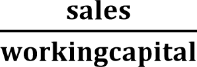



=570.57 times

* YEAR 2022

Working capital turnover =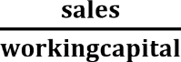



**= 32.33 times**

|  |  |  |  |
| --- | --- | --- | --- |
| **Year** | **Net sales** | **Working capital** | **ratio** |
| **2021** | 47522.69 | 83.29 | 570.57 times |
| **2022** | 57507.93 | 1778.99 | 32.33 times |

* LEVERAGES

YEAR 2021

|  |  |
| --- | --- |
| **Sales** | **47522.69** |
| Less: V.C  Manufacturing expenses Power & fuel cost  Employee cost | 1376.29  1243.10  782.30 |
| **3401.69** | |
| **Contribution** | **44121** |
| Less: F.C depreciation | 980.94 |
| **EBIT** | **43140.06** |
| Less: interest | 195.02 |
| **EBT** | **42945.04** |

* Operating leverages =

**= 1.02**

* Financial leverages 



**= 1.00**

* Combine leverages

= 1.02

YEAR 2022

|  |  |
| --- | --- |
| **Sales** | **57507.93** |
| Less: V.C.  Manufacturing expenses Power & fuel cost Employee cost | 1299.51  1675.50  843.50 |
| **3818.51** | |
| **Contribution** | **53689.42** |
| Less: F.C. depreciation | 1176.15 |
| **EBIT** | **52513.27** |
| Less: interest | 366.19 |
| **EBT** | **52147.08** |

* Operating leverages = 



**= 1.02**

* Financial leverages = 



**= 1.01**

* Combine leverages 

**= 1.03**

What is Accounting Procedure?

The accounting procedure is defined as the process of standardized nature that performs a specific accounting function designed to incorporate better risk management policies so that these functions are completed more productively and efficiently. The accounting department performs several functions, such as billings for their customers, providing invoices to suppliers, and performing bank reconciliation; hence such tasks normally require comprehensive and streamlined procedures.

**Characteristics of Accounting Procedure**

1. – Collection of Financial Information

It begins with the collection of financial documents. The information collected may be logged and maintained through physical or electrical modes. The cash register tapes, incoming bills, receipts, records of salaries, travel receipts, forms, and invoices are examples of financial documents.

1. – Account Reconciliation and Verification

Once logged into the system, the accountants verify the financial information

with the available evidence. Account

reconciliation and internal and external reporting are performed as per the established accounting procedures. These procedures should be designed and constructed so that it records valid, objective, and accurate information. In addition, the procedures should be consistent and comparable.

**Examples of Accounting Procedures**

Example 1

The best example to describe the above point is that of inventory valuation

. Once it is determined that inventories are to be recorded and valued using the First-in first-out inventory method

, it should not be changed to any alternative valuation method such as that to either the LIFO inventory method

or weighted average method.

**Advantages**

IT helps in the process of decision making as it provides a framework and also an effective division of work between accounting departments

.

Different accounting procedures require different levels of specialization and skills to record the information into the accounting systems.

It helps in recording of information of financial nature and non- financial nature.

It ensures that the recorded information can be cross-verified. It helps makes financial statements of uniform in nature and which could be utilized for industry analysis

.

Applying the right accounting procedures ensures efficiency and time-saving in recording information into the system.

It ensures that the business records are maintained in chronological order.

It ensures that the business complies with all legal and regulatory compliance.

**Disadvantages**

The accounts maintained and formed as per accounting procedures can be easily manipulated if the processes are not revised as per the present applicable guidelines prescribed as per the accounting standards and legal compliance.

The information shared and prepared through adopted procedures may be biased due to human errors and judgments.

Non-compliance with accounting principles

in the procedures may result in incorrect information recording.

It helps in the division of work among different departments. Still, it also creates unnecessary silos, which in turn produces difficulty in the reconciliation process of the financial information.

***Chapter 5 HUMAN RESOURCE DEPARTMENT***

* + **ORGANIZATIONAL CHART**

City manager's

office

Human

Resourc director

Human

resources generalist

Office associate

**HUMAN RESOURCE PLANNING-PROCESS**

“The process that links the human resources to its needs of an organization strategic plan to ensure that staffing is sufficient, qualified, and competent enough to achieve the organization’s objectives.HR planning is becoming a vital organization element for maintaining a competitive advantage and reducing employee turnover”

Human resource planning is a process through which the company anticipates future business and environmental forces. Human resources planning assess the manpower requirement for future period of time. HR planning is a continuous process which starts with identification of

HR objectives, move through analysis of manpower resources and ends at appraisal of HR planning. Following are the major steps involved in human resource planning-process:



ASSESSING HUMAN

RESOURCES

DEMAND

FORECASTING

SUPPLY FORCASTING

MATCHING

DEMANDAND SUPPLY

ACTION PLAN

1. **ASSESSING HUMAN RESOURCES:**

The assessment of HR begins with environmental analysis, under which the external and internal are analyzed to assess the currently available HR inventory level. After the analysis of external and internal forces of the organization, RAJ WAFER will be easier for HR manager to find out the internal strengths as well as weakness of the organizations in one hand and opportunities and threats on the others. Moreover, RAJ WAFERS includes an inventory of the workers and skills already available within the organization and a comprehensive job analysis.

1. **DEMAND FORECASTING:**

HR forecasting is the process of estimating demand for and supply of HR in an organization. Demand forecasting is a process of determining future needs for HR in items of quantity and quality of RAJ WEFERS. It is done to meet the future personal requirements of the organization to achieve the desired level of output.

Future human resource need can be estimated with the help of the organization’s current human resource situation and analysis of organization plans an procedures. RAJ WAFER will be necessary to perform a year-by-year analysis for every significant level and type.

1. **SUPPLY FORCASTING:**

Supply is another side of human resource assessment. It is concerned with the estimated of supply of manpower given the analysis of current resource and future availability of human resource in the organization. RAJ WAFER estimates the future sources of HR that are likely to be available from within an outside the organization. Internal sources include promotion, transfer, job enlargement and enrichment, whereas external sources include recruitment of fresh candidates who are capable of performing well in the organization.

1. **MATCHING DEMAND AND SUPPLY:**

It is another steps of human resource planning. RAJ WAFER concerned with bringing the forecast of forecast demand and supply of HR. The matching process refers to brings demand and supply in an equilibrium position so that shortages and over staffing position will be solved. In case of shortages an organization has to hire more required number of employees. Conversely, in the case of over staffing it has to reduce the level of existing employment.

1. **ACTION PLAN**:

It is the last phase of human resource planning which is

concerned with surplus and shortage of human resource. Under it, the HR plan is executed through the designation of different HR activities. The major activities of RAJ WAFERS which are required to execute the HR plan are requirement, training and development, socialization etc. Finally, this step is followed by control and evaluation of performance of HR to check whether the HR planning matches the HR objectives and policies. This action plan should be change updated according to change in time and conditions.

* + **RECRUITMENT & SELECTION – PROCESS:**

* *RECRUITMENT: -*



*In simple term, recruitment is understood as the process of searching for and obtaining application for jobs, from*

*among whom the right people can be selected.*

*According to E. Durbin B. Flippo, “recruitment*

*is a process of searching for prospective employees and stimulating and encouraging them to apply for jobs in an organization.*

* *RECRUITMENT PROCESS OF RAJ WAFERS*



PLANNING

SEARCHING

SCREENING

*The recruitment process of RAJ WAFERS starts with personal* planning of general manager. When there is ant sit become vacant or a new employee is or are require, general manager fist plan how many employees are and of what qualification. General Manager decides which type of people is requiring means which type of skills an employee have need recruitment. So, the first step of RAJ WAFERS is set a standard for recruitment.

*The second step is searching for employees. General Manager* decides from were. The employee is recruit and by which source. The middle level of employees and worker are mostly recruiting from city areas which are near to company. In source for recruiting, general manager user both internal and external source of recruiting.

###### * *INTERNAL SOURCE: -*

* *Relative of present employee*
* *Promotion*
* *Former employees*
* *Internal source is use when more employees are required.*

###### * *EXTERNAL SOURCE: -*

* *Advertisement in newspaper.*
* *Advertisement in television and radio.*
* *The third steps are screening for collected applications received in response to advertisement are screened and only eligible application are called for an interview. Here the recruitment process is ending the selection process begins.*

###### * *SELECTION: -*

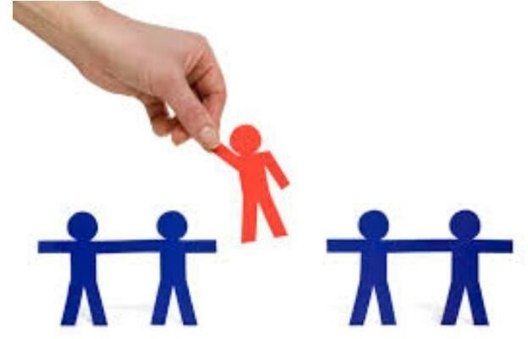

*Selection is the process by which candidate for employment are divided into class those who will be offered employment and those. Thus, the selection process is a tool in the hand of the management to differentiate the qualified and unqualified application by applying*

*various techniques such as interview, tests.*

* + *PROCESS OF SELECTION: -*



PRELIMINARY

INTERVIEW

SELECTION TEST

EMPLOYMENT

INTERVIEW

REFERENCE AND

BACKROUND CHECKS

SELECTION DECISION

JOB OFFER

EVLUATION

*Selection process starts when recruitment processed. The steps of* selection process are as follow:

###### *PRELIMINARY INTERVIEW:*

*It explains that application received from the job seekers would* be subjected to eliminate unqualified applicants.

*It enables the HR specialists to eliminated unqualified job* seekers based on the information supplied on the application forms.

###### *SELECTION TEST:*

*Job seekers who pass the screening and the preliminary interview are* called for selection test.

*These tests are used to determinant the applicant’s ability, aptitude, and*

*personality.*

*These are different types of tests which have been conducted to see the*

*applicant’s ability.*

* *Ability test*
* *Aptitude test*
* *General management aptitude*
* *Personality test*
* *Interest test*
* *Graphology test*
* *Choosing test*
* *Intelligence test*

###### *EMPLOYMENT INTERVIEW:*

* *Selected candidates are called for interview. Interview is arranged to measure the qualities like self-confidence, balance of mind etc. this quality cannot be measured by test.*
* *Interview is a formal, in-depth conservation conducted to evaluate the applicant’s acceptability. Interview is arranged to measure the qualities like expression, self-confidence, balance of mind etc.*
* *The employment interview can be of different types, they are*
  1. *One interview*
  2. *Sequential interview*
  3. *Panel interview*

###### ***3.*** *REFERANCE AND BACKGROUND CHECKS*

* *Knowing details about the employer's name, address, and telephone numbers for reference for the purpose verifying the information.*
* *Previous employees, known public figures, Neighbours or friends can act as*

*reference.*

* *Previous employees can preferable because they can already aware of the applicant's performance.*

###### *SELECTION DECISION*

* *After getting information through preceding steps, selection decision, the most*

*critical of all steps.*

* *The final decision has to be made from the pull of the individuals who pass the*

*test, interview and reference cheeks.*

* *The HR manager plays the crucial role in the final selection.*

###### *PHYSICAL EXAMINATION*

* *After the selection decision and before the job offer is made, the candidate is made to undergo a physical fitness and selected candidates they are sent for medical check-up.*
* *The reason for physical fitness is the detect if the person carries any infectious*

*disease.*

* *A man with poor health may be dropped even at this stage also.*
* *And to make sure weather the person is physically fit to perform the work.*

###### *JOB OFFER*

* *The job offer is made through a letter of appointment.*
* *Which contains a date by which the appointment must report on duty?*

###### *EVALUATION*

* *A Particular person is selected for a particular job.*
* *The final step in the selection process is the evaluation of selection.*
* *Usually, the feedback is got from the people who have been selected.*
* *Placement is made the supervisor under the employee to perform duty.*

###### *No. Of employee: -*

*RAJ WAFERS has 40 total employees across all of its*

*locations.*

* + *TRAINING GIVEN*

*RAJ WAFERS Company provides the training for the senior* manager. Because of the update of the new technology. Now a day we can see that every few months technology change and manager have to knowledge of how to operate the new machine or technology.

*Company appoints the special person for teach the senior* manager. This person is market expert, she has the good knowledge of the real market situation and they help the company to survive and grow up in the market. The trainer is teaching the manager how to increase the profile in different ways. This kind of training is very important for manager and as well as company.

###### *Leave Rules: -*

* *Before 12 AM it will be considered as a Full leave.*
* *After 12 AM it will be considered as a Half leave.*
  + *Employee safety mechanism: -*

*Raj wafers providing a safe working environment for employees* by incorporating safe equipment and safe procedures at the workplace to ensure worker safety.

###### *Promotion Rules: -*

*Employees have five years working experience requirement in Raj* Wafers and also depends on Working Skills..

###### *Specific HR Policies: -*

* *Employment contract.: - Minimum 1 years*
* *Employee wages.: - 300 Rs Per Day*
* *Code of Conduct.: - Integrity, Objectivity, Professional Behavior.*
* *Employee provident fund: - The PF contribution of 12% should be divided equally between the employer and employee. The employer's contribution is 12% of the basic salary. If the establishment has employed less than 20 employees, the PF deduction rate will be 10%.*
* *Gratuity Policy: - The Act provides for payment of gratuity at the rate of 15 days wage s for each completed year of service subject to a maximum of Rs. ten lakhs. In the case of seasonal establishment, gratuity is payable at the rate of seven days wages for each season.*
  + *Performance appraisal*

*A performance appraisal is a regular review of an* employee's job performance and contribution to a company. Raj Wafer use performance appraisals to determine which employees have contributed the most to the company's growth, review progress, and reward high-achieving workers.

###### *Wages and Salary Administration*

*In Raj Wafers the wages given to the labours per day 300 Rs and salary will be according to their post.*

* *Grievance and Handling Procedure 1 .Acknowledge Dissatisfaction: ...*

1. *Define the Problem: ...*
2. *Identify and Collect the Facts: ...*
3. *Carry out Analyse and Decide: ...*
4. *Timely Action: ...*
5. *Taking Decision: ...*
6. *Implementing the Decision: ...*
7. *Follow up Action:*

***Chapter 6 PURCHASE DEPARTMENT***

***Purchase Procedure***

* 1. **Purchase Procedure :-**

*The process describes the sequence of steps leading to the completion of* an identified specific task. Thus, purchasing process describes the sequence of steps by which purchase function is carried through from its inception to it completion. The steps of process are as follows

#### *Receive requisitions*

*The requisition includes information like how many items wanted, when* they should be available, quantity in hand, who is making the request etc.

*In “RAJ WAFERS”, who requires raw materials or other things, they give* “purchase requisition slip” to production department.

#### *Review requisitions*

*The review of requisition is necessary. This is done to answer questions like:*

* + - *Can a less expensive material serve purpose?*
    - *Can it be eliminated?*
    - *Can another item serve the same function?*
    - *Can a supplier reduce price by revise specification?*

#### *Select suppliers*

*“****RAJ WAFERS****” is co-operative pharmacy and for purchase they invite* quotation from various suppliers. After getting quotations and by comparing them

*“****RAJ WAFERS****” select the suppliers. “****RAJ WAFERS****” is not giving so much* important to price but give important to quality.

#### *Place orders*

*Orders are placed to selected suppliers. For order placing to selected* suppliers, “***RAJ WAFERS****” prepare a purchase order and send to suppliers.* Purchase order includes specific quantity and quality of material at stipulated terms and material send period and placed mentioned in it.

#### *Monitor orders*

*If placed order is for long time then it is necessary to monitor those orders.* “***RAJ WAFERS****” also monitor these types of orders because lengthy orders are* checked to determine whether anticipated deliveries are on schedule.

#### *Receive orders*

*The purchase transaction is complete only after receiving the order* quantity in an acceptable condition. When material is comes in “***RAJ WAFERS****”,* it is checked for quality in “***RAJ WAFERS****”‘s laboratory. If qualities acceptable* then only material is send to store department with material inward receipt.

|  |
| --- |
| *“****RAJ WAFERS****”*  Plot No. 2 Block No. A/12,, Shagun Industrial Estate,, Olpad-sayan Road, At. Atodara, Ta. Olpad., SURAT.  *PURCHASE ORDER* |
| ***Purchase Order No:***  ***Supplier Quotation:*** |

|  |  |  |  |  |  |  |  |
| --- | --- | --- | --- | --- | --- | --- | --- |
| ***TO: No. & Date:***  ***Please supply the following items on the terms and condition mentioned below.*** | | | | | | | |
| ***Sl No*** | *Description* | *Material*  *code* | *size* | *Qty.* | *Price* | *Amount* | *Delivery*  *date* |
|  | | | | | | | |
| ***Terms of delivery……..*** | | | | | | | |
| ***For “RAJ WAFERS”***  ***Purchase***  ***Manager*** | | | | | | | |

|  |
| --- |
| *PURCHASE REQUISITION FORM*  *“****RAJ WAFERS****”*  Plot No. 2 Block No. A/12,, Shagun Industrial Estate,, Olpad-sayan Road, At. Atodara, Ta. Olpad., SURAT.  Gujarat 394130  *Phone no : 648092, 644410* |
| ***Sr. no. Date:*** |

|  |  |  |  |  |  |  |  |  |  |
| --- | --- | --- | --- | --- | --- | --- | --- | --- | --- |
| ***Materi***  ***al code*** | *Description*  *o-* | *Size*  *-* | *Qty*  *--* | *Job/dep*  *t-* | *Delivery* | | *Purchase order* | | |
|  |  |  |  |  | *Dat*  *e* | *Pric*  *e* | *No*  *.* | *Rat*  *e* | *Supplie*  *r* |
|  | | | | | | | | | |
| ***Authorized Signature*** | | | | | | | | | |

#### *What Is Purchase Lead Time (PLT):-*

*Purchase lead time (PLT) refers to the number of days from when a* company places an order for production inputs it needs, to when those items arrive at the manufacturing plant. Put simply, a PLT is the estimated time in which it takes to receive an order after it’s placed. Purchase order lead times vary from company to company and from industry to industry, and depend on many factors such as the types of goods or materials being ordered, their relative abundance or scarcity, where the suppliers are located, and even the time of year.

#### *KEY TAKEAWAYS*

*Purchase lead time is the number of days from when a company places an* order for supplies, to when those items arrive.

*The PLT depends on the types of supplies ordered, their relative abundance* or scarcity, where the suppliers are located, and even the time of year.

*Companies must carefully plan purchase order lead times when planning* a manufacturing run.

*Companies can cut down on order times by increasing the number or* orders, changing suppliers, and automating the order process.

#### *Understanding Purchase Lead Time*

*As mentioned above, the purchase lead time is how long it takes for an* order to be fulfilled—from the time the order is placed until the estimated date of receipt. So if a company places an order for supplies on May 1 and it’s expected to be delivered on May 10, the PLT for the supplies is nine days. The PLT includes a number of different steps including the confirmation of the order, availability of the goods, the order placement, acknowledgement of the order, the shipping notice, receipt of the goods, invoicing, and payments

*Companies must carefully plan purchase order lead times when planning* a manufacturing run because if production inputs do not arrive on schedule, manufacturing will be delayed, costing the company money in lost sales, idle worker time, and lower factory overhead absorption. On the other hand, if inputs arrive too early, the company could incur additional inventory storage costs

*this reason, managers need to plan as precisely as possible when they need* to order the materials needed, lest they incur additional overhead. If they have a trusted supply chain, this should be one of the first items added to a production and/or staffing calendar

#### *Ordering Costs and carrying costs:-*

* + - ***Ordering Cost***

*Cost of procurement and inbound logistics costs form a part of Ordering* Cost. Ordering Cost is dependant and varies based on two factors - The cost of ordering excess and the Cost of ordering too less.

*Bothered these factors move in opposite directions to each other. Ordering* excess quantity will result in carrying cost of inventory. Where as ordering less will result in increase of replenishment cost and ordering costs.

*These two above costs together are called Total Stocking Cost. If you plot* the order quantity vs the TSC, you will see the graph declining gradually until a certain point after which with every increase in quantity the TSC will proportionately show an increase.

*This functional analysis and cost implications form the basis of* determining the Inventory Procurement decision by answering the two basic fundamental questions - How Much to Order and When to Order.

#### *Carrying Cost*

*Inventory storage and maintenance involves various types of costs namely:*

* + - *Inventory Storage Cost*
    - *Cost of Capital*

*Inventory carrying involves Inventory storage and management either* using in house facilities or external warehouses owned and managed by third party vendors. In both cases, inventory management and process involves extensive use of Building, Material Handling Equipment’s, IT Software applications and Hardware Equipment’s coupled managed by Operations and Management Staff resources.

#### *Inventory Storage Cost*

*Inventory storage costs typically include Cost of Building Rental and* facility maintenance and related costs. Cost of Material Handling Equipments, IT Hardware and applications, including cost of purchase, depreciation or rental or lease as the case may be. Further costs include operational costs, consumables, communication costs and utilities, besides the cost of human resources employed in operations as well as management.

#### *Cost of Capital*

*Includes the costs of investments, interest on working capital, taxes on* inventory paid, insurance costs and other costs associate with legal liabilities.

*The inventory storage costs as well as cost of capital is dependant upon* and varies with the decision of the management to manage inventory in house or through outsourced vendors and third party service providers.

*Current times, the trend is increasingly in favour of outsourcing the* inventory management to third party service provides. For one thing the

*organizations find that managing inventory operations requires certain core* competencies, which may not be inline with their business competencies. They would rather outsource to a supplier who has the required competency than build them in house.

*Secondly in case of large-scale warehouse operations, the scale of* investments may be too huge in terms of cost of building and material handling equipments etc. Besides the project may span over a longer period of several years, thus blocking capital of the company, which can be utilized into more important areas such as R & D, Expansion etc. than by staying invested into the project

#### *General Details Purchasing Department:-*

*The purchasing department of a company is responsible for procuring the* goods, raw materials & services required to operate the organization effectively.

*Now, every organization has its specific needs when it comes to the* sourcing and procurement of equipment, raw materials, and services. These needs define the purchasing process and how its purchasing department functions.

*Based on these needs, an organization sets the purchasing department’s* responsibilities and streamlines its procurement plans to guard against demand- supply hurdles. Let’s understand the role of a purchasing department in this process.

#### *Key Functions of Purchasing Departments*

*All purchasing department functions are aligned with the business* objectives of an organization. Here are some of the basic purchasing department functions:

* + - *Identify business requirements for goods, materials, and services*
    - *Find reliable suppliers to meet these requirements*
    - *Negotiate prices, build quality, and delivery terms*
    - *Set up the order quantities and making bid requests on supply contracts*
    - *Coordinate delivery and storage operations*
    - *Run quality control and product testing*
    - *Manage budgets based on ROIs and payments*

#### *Raw Material order*

* *Potato 4000 kg. per/ month.*
* *Masala – manufatcher.*
* *Salt - Rock salt (Hathi company) 1kg.in packaging 500 kg. Per month.*
* *Cashew nut 30kg. Per month.*
* *Raisins 25kg. Per month.*
* *Peanuts 30kg. Per month.*

#### *LIST OF SUPPLIERS*

###### *There are 70 active raj wafer suppliers in Gujarat.*

* *Top 3 raj wafers supplier are in Surat, Bardoli and Mehsana.*

**Ch 7:-Safety Department**

* 1. No of fire extinguishers:-
* Carrying out a fire risk assessment will determine the type and number of fire extinguishers required.
* Fire extinguishers for use on Class A fires, flammable solids such as paper, wood, textiles, are rated on their ability to extinguish test fires. The test rating is clearly displayed on the extinguisher label.
* British Standard 5306 has a formula for calculating the number of class A extinguishers needed. As a general rule one 13A extinguisher covers 200 square meters.
* However, the BS 5306-8 2012 update recommends that each storey with a floor area less than or equal to 400m² should have at least 2 extinguishers, with a minimum combined fire rating of 26A.
* For any storey with a floor area exceeding 400 m² the A rated extinguishers should have a combined minimum fire rating of 0.065 x floor area of the storey (in square metres). In basic terms, for every additional 200m² you require an extra 13A extinguisher.
* Try our floor space calculator below to work out how many Class A extinguishers you need.

**Fire Extinguisher**

|  |  |
| --- | --- |
| Fire Extinguisher Type | A B C Dry Powder Type |
| Capacity | 4Kg |

* 1. **Safety Equipment provided to workers:-**

|  |  |
| --- | --- |
| Material | Mild Steel |
| Certification | ISI |
| Features | ABC Type Fire |
| Weight | 6 kg |
| Size | 5 kg |
| Model Number | 2019 |
| Metal Used | M Steel |
| Time Of Extinguishing | 5 year |

Safety is equipment that will protect the user against the risk of accidents or of adverse effects on health. It can include items such as safety helmets, gloves, eye protection, high-visibility clothing, safety footwear, safety harnesses and respiratory protective equipment (RPE)

**Why is Safety important**

Making the workplace safe includes providing instructions, procedures, training and supervision to encourage people to work safely and responsibly.

Even where engineering controls and safe systems of work have been applied, some hazards might remain. These include injuries to:

* + the lungs, e.g. from breathing in contaminated air;
  + the head and feet, e.g. from falling materials;
  + the eyes, e.g. from flying particles or splashes of corrosive liquids;
  + the skin, e.g. from contact with corrosive materials;
  + the body, e.g. from extremes of heat or cold.
  + Safety is needed in these cases to reduce the risk.

**Emergency equipment**

Careful selection, maintenance and regular and realistic operator training is needed for equipment for use in emergencies, like compressed-air escape breathing apparatus, respirators and safety ropes or harnesses.

* 1. **Workmen’s Compensation policy:-**

Workmen’s Compensation Insurance (which is also known as Workers' compensation insurance or Employees Compensation Insurance) is a type of insurance policy that is there to provide coverage for your business’s employees who are injured or become disabled as a result of their jobs.

Even if you take all kinds of preventive measures, workplace accidents can unfortunately occur, and having this insurance will provide your employees with compensation without leaving your business at a financial loss.

Workmen's compensation insurance is set out under the Workmen's Compensation Insurance Act, 1923 and is there to protect you financially while still providing your employees with help in such situations.

* 1. **List of General Insurance Policies (Fire, Marine, Burglary etc.)**:-

A general insurance policy comprises a range of insurance plans other than life insurance products. The types of general insurance policies include fire insurance, burglary insurance, marine insurance, and so on. The general insurance policy offers coverage to policyholders to compensate their damages or losses incurred from a specific incurred. In simple terms, general insurance is insurance which is not life insurance.

The tenure of general insurance does not last for a lifetime, as happens under the life insurance policy, but it is scheduled for a particular incident or for a duration. The majority of general insurance products come with annual contracts, while some of them are also available as long term.

* + - **Marine Insurance:-**

Many businesses are run with the import and export of goods, within national and international borders. Sometimes, this movement of goods can be affected with the risk of mishaps, which can result in damage or destruction of shipments leading to significant financial losses. Therefore, marine cargo insurance policy gives coverage to goods, freight, cargo, etc., against loss or damage during transit by rail, road, sea and/or air.

In addition to this, shipments are secured from the time the goods leave the seller’s warehouse until they reach the buyer’s warehouse. In short, this insurance offers complete financial protection during the transit of goods and compensates in the event of any loss suffered. Different types of marine insurance plans are open cover, annual policy, voyage policy and so on.

* + Fire Insurance:-

Fire insurance is a legal contract between the insurer and the insured. It provides coverage to the policyholder against any loss or damage caused by fire. Not all home insurance policies cover damages caused by fire but insurance companies offer add-ons that can be purchased separately by the policyholder if required. Purchasing this coverage will help and cover the replacement, reconstruction and replacement cost of the property but there are certain exclusions such as damage caused due to war or war-like situations.

* + **Burglary Insurance:-**

A burglary insurance policy is a type of crime insurance that covers losses resulting from burglary. Put simply, burglary refers to when someone uses force to unlawfully enter someone else's property - even if they did not steal anything in the end.

Types of losses insured include:

* + Theft of property from a closed premises such as a home, place of business or automobile.
  + Damage caused by the intruder in the process.
  1. **Health and Safety Policy:-**

A health and safety policy is an organization's statement regarding its commitment to maintaining a safe and healthy work environment. In the United States and Canada, employers are legally required to maintain a safe and healthy

workplace. An employer's health and safety policy communicates this safety

commitment and obligation to each individual employee. Similar to a health and safety program, the size and scope of an employer's health and safety policy will depend on the size and needs of the particular organization

* + - **Workplace Testing Explains Health and Safety Policy**

A health and safety policy is serves as the guide for an employer's health and safety program. The health and safety policy describes in broad terms the requirements for an employer's program. A health and safety policy should include a statement of the employer's commitment to workplaces safety and its employees' obligation to support the policy. A well-written policy will also include standards for accountability and enforcement of the policy.